

User Guide

April 2020





Real Life

Life Changing

Changing Healthcare

Copyright

NAVVIS Coreo Home User Guide

Copyright

Copyright © 2019 NAVVIS & Company, LLC. All rights reserved.

The information in this User Guide may change without notice.

Trademarks

We acknowledge all product names, trade names, or corporate names we mention in this User Guide to be the proprietary property of the registered owners.

Disclaimer

Names and personal information used in this document are purely fictitious and do not refer to real names or persons.

This User Guide is not guaranteed to be error-free and is provided "as is" without warranty of any kind, whether express, implied, or statutory. The User Guide may be inaccurate, incorrect, invalid, untrue, false, incomplete and/or misleading. The entire risk as to the quality, correctness, accuracy, or completeness of the content of this User Guide is with you. The author(s), owner(s), publisher(s), and administrator(s) of this User Guide, and applicable intellectual property owner(s) disclaim any and all warranties of any kind.

Disclaimer of Liability

The author(s), owner(s), publisher(s), and administrator(s) of this User Guide, and applicable intellectual property owner(s) disclaim any and all liability and in no event will any of those parties be liable to you or to any other party for damages, including, but not limited to, any direct, indirect, general, special, incidental, punitive, exemplary, or consequential damages (including, but not limited to, any losses sustained by you or third parties, procurement of substitute services, or business interruption), whether in contract, strict liability, tort (including negligence) or otherwise, arising out of any use of this User Guide or the content thereof or of any third-party website or content linked in any way from this User Guide, even if such damages (or possibility of such damages) are/were predictable or known to the author, owner, publisher, administrator, or any other party.

No part of this document may be reproduced or transmitted in any form or by any means, electronic or mechanical, for any purpose, without the express written approval of Navvis & Company, LLC.

Table of Contents

Preface 6

About Navvis Coreo Home 6

About Navvis Healthcare 6

Purpose of this Document 7

Intended Audience 7

Organization of the Document 7

Conventions 7

Browsers Versions for Coreo Home 8

Section I: Individual User 9

1 Individual Member Onboarding 10

2 Individual Profile 14

2.1 Update or Review Your Profile 15

3 Set Up Payments 21

4 Individual User Dashboard 22

4.1 Get to Know the Calendar Panel 23

4.1.1 Coreo Home Mobile Device App for Individual users 24

4.2 Using the Wizard 26

4.3 Browse Providers 26

4.4 Engage Provider 27

4.5 Create and Post a Service Request 29

4.5.1 Service 30

4.5.2 Preference 31

4.5.3 Questionnaire 35

4.5.4 Review 35

4.6 Visit(s) Schedule 36

4.7 Submit Feedback 40

5 Header Bar 43

5.1 Video Conferencing 43

5.2 Messaging 44

5.3 Profile Icon 46

6 Settings–Configure Notifications 47

Section II: Guardian User 49

1 Guardian Onboarding 50

Guardian Profile 53

1.1 Guardian–Be a Guardian to the Individual that You Add 55

1.2 Member–You are the Member Needing Services 57

2 Acting on Behalf of a Dependent Member 58

3 Accounts of Inactive and Deceased Dependents 58

Section III: Entity User 60

1 Entity User Onboarding 61

2 Entity User Profile 63

2.1 Update or Review Your Profile 64

3 Dashboard 66

3.1 Individuals Tab 66

3.1.1 Individuals in Total in the Population 66

3.1.1.1 Processing the Visit on Behalf of the Entity Service Provider 67

3.1.2 Individual with Feedback Alerts 68

3.1.3 Individuals with Visits in the Period 68

3.2 Service Providers Tab 69

3.2.1 Providers in Total in the Population 69

3.2.2 Providers with Feedback Alerts 70

3.2.3 Providers with Visits in the Period 71

3.2.4 Providers with Low Ratings 71

3.2.5 Providers with Low Task Completion 72

3.3 Service Requests Tab 72

3.3.1 Requests in Total in The Population 72

3.3.2 Requests with Open Status 74

3.3.3 Requests Cancelled in the Period 74

3.4 Service Visits Tab 74

3.4.1 Visits in Total in the Population 74

3.4.2 Visits Overdue in the Period 75

3.4.3 Visits with Low Task Completion 75

3.4.4 Visits Cancelled in The Period 75

4 Video Conferencing, Messaging, and Settings 75

5 Engaging with a Patient 76

5.1.1 Schedule Type–Assessment 78

5.1.2 Schedule Type–Standard 79

5.1.3 Entity Process 83

6 Inactive and Deceased Individuals 84

Section IV: Entity Service Provider (ESP) User 86

1 ESP Onboarding 87

2 ESP Profile 87

3 Dashboard 89

3.1 Coreo Home Mobile Device App for ESPs 90

3.2 Start the Visit Process 91

Section V: Care Team User 95

1 Care Team Dashboard 96

1.1 Individuals Tab 96

1.1.1 Care Team User Acting on Behalf of the Patient 97

1.1.1.1 Mobile App Interface for Care Team Users 98

1.2 Service Providers Tab 100

1.3 Service Requests Tab 102

1.4 Service Visits Tab 105

2 Handling Inactive and Deceased Individuals’ Accounts 105

3 Video Conferencing and Messaging 106

4 Geomap View 106

5 Glossary 108

6 Index 110

Preface

Welcome to the release of the NAVVIS Coreo Home User Guide.

About Navvis Coreo Home

Navvis Coreo Home is a HIPAA (Health Insurance Portability and Accountability Act)-Compliant cloud solution. It is an element of the Coreo ecosystem that engages and guides individuals to caregiver and community services.

The Coreo Home platform is an extension of Navvis Solution to coordinate, engage and guide patients with community Service Provider services driving a paradigm shift in Navvis’s mission to never stop caring as a holistic approach to population management. The goal is to serve as a catalyst to create a sustainable community system that advances the health and well-being goals of consumers, providers, employers, communities, and government.

Coreo Home represents another tool to support the Navvis Solution, which allows the management and delivery of care across the full continuum of health.

The Coreo Home solution facilitates the delivery of a wide array of services for patients and members in need of care for their physical, mental, and social needs. Some of the examples of the types of services supported by Coreo Home that would be provided by service providers and community resources are illustrated in the following image:



About Navvis Healthcare

Navvis Healthcare provides counsel to health systems, hospitals, and physician groups in the following areas:

* Development of innovative
* Providing market-linked strategies to build future-ready health systems
* Cultivating tomorrow’s leaders and strengthening strategic performance

Purpose of this Document

This guide is the primary source of information about the Navvis Coreo Home application. It contains overviews, processes, and procedures to use the Coreo Home application effectively.

You can refer to the Navvis Unified Ecosystem Experience (UEE) User Guide and the Navvis Coreo View User Guide for additional sources of information.

Intended Audience

1. **Users**: The users of the Coreo Home application include the following personnel:

* Employees, consultants, contractors, or agents of the clinicians or patients who have been invited by the clinician or patient to access and use the service to participate in the care of the patient
* Any other person involved in the care of the patient, including patient's care providers, patient's insurer or payer, or a social worker, or government agencies
* Entities and Organizations involved in community services catering to the physical, mental, and social needs of the population.

1. **Care Team Users:** The Coreo Home care-team users are assigned the task of managing other users of the Coreo Home application.

Organization of the Document

This document contains the following modules:

Section I: Individual User

Section II: Guardian User

Section III: Entity User

Section IV: Entity Service Provider User

Section V: Care Team User

Conventions

This document uses the following conventions:

| Convention | Item |
| --- | --- |
| **Boldface** font | **Menu** items, **Tab** names, **Text** **box** names, **List** **box** names, **Button** names and **Navigation** paths as displayed in the Coreo Home application user interface (UI) |
| *Example* | *Examples to leverage the concepts* |
| Text in blue | Hyperlinks |
|  | Note: Notes contain helpful suggestions. A note informs the reader about any deviation in the sequence of instructions or helps the reader save time in understanding why something is not working. |

Browsers Versions for Coreo Home

The Coreo Home application is available on desktops, laptops, IOS devices, and Android tablets on the browser versions, as mentioned in the following table, and on higher browser versions:

| Browser | Version |
| --- | --- |
| Google Chrome | 80.0.3 |
| Safari | 11.1.2; 13.0.5 |
| Internet Explorer | 11.16 |
| Firefox | 74.0 |

Section I: Individual User

# Individual Member Onboarding

Let’s get started with the Coreo Home application. You will receive an invitation email from the Navvis administrator to your registered email address, or a text message to your registered phone number.

Follow these steps to create your Coreo Home account as an individual user:

1. Click the Invitation link in the email or message. The link leads you to a screen that guides you through the onboarding process.
2. On the first onboarding screen, select the **Member** option and click **NEXT**.



1. Choose your profile type
2. Enter your first, middle, and last name, your gender, phone number, date of birth, and your email address on the **Create my user** screen. The email address is the username login ID for your Coreo Home account.



1. Create my User
2. Click the **SEND VERIFICATION LINK** button. You will receive a verification link in your email address that you just entered.
3. Go to your mail inbox and click the set password link to set the password for your account.



1. Verification Email
2. On the **Set My Password** screen, enter a new password for your Coreo Home account and reenter the same password in the **Confirm New Password** box.



1. Set My Password screen
2. Choose a security question from the drop-down list.
3. In the **Answer** box, enter the answer. Remember this answer because you have to use it at a later date to reset a forgotten or expired password.
4. Click the **End User License Agreement** link to open the End User License Agreement (EULA) screen.



1. EULA screen

The EULA screen displays when you sign in as a first-time user of the Coreo Home application. You are required to accept the EULA terms and conditions before completing your profile creation.

1. Select the **Acknowledge and Accept** button after reading the terms and conditions.
2. On the **Set My Password** screen, select the check box after accepting the EULA.



1. Select the **SUBMIT** button to complete the password setting. You are taken to the **Create a Profile** screen.



1. Create a Profile
2. Enter your address details and click **NEXT**.

Adding your guardian is an optional step. You can add your guardian details even after signing into your account.

You are onboarded successfully on completing all the steps.



1. Click the **Continue** button to proceed with the sign-in.
2. On the Welcome screen, enter your registered email address, which is your user name, and enter the password.



1. Select **Login** to sign in to your Coreo Home account. As a first-time user, Coreo Home takes you to the **Browser Provider** screen.

To sign in to your account as an existing user, go to <https://pftest-gen.coreoflowsandbox.com/#/>. An individual user, a guardian user, and a care team member have the same sign-in screen.

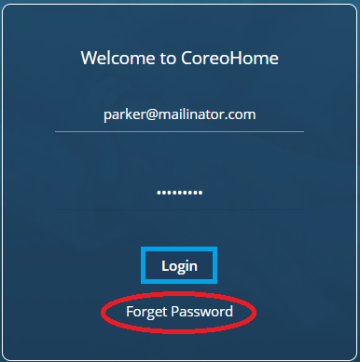

1. Coreo Home Sign In screen

During subsequent logins, in case you forget your password, click the **Forget Password** button on the Welcome screen. Coreo Home guides you through a series of steps to reset a new password for your account.

Inactive and Deceased Patient Accounts

Patients in Coreo Analytics and Coreo Home are flagged as **Inactive** due to multiple reasons. The primary reasons are when the member doesn’t meet the eligibility criteria of the health plan or when the contract has expired.

If you are an inactive patient, you cannot sign in to your Coreo Home user account.

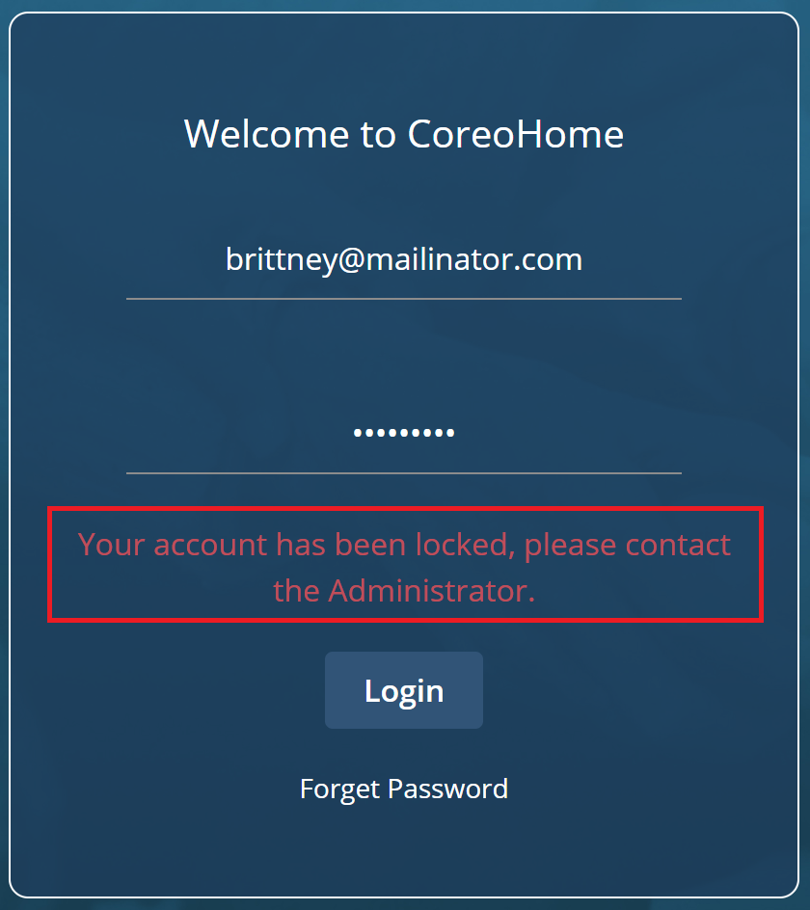

1. sign in for an Inactive or a Deceased patient account

When you try to sign in to an inactive account, you get the following message: Your account has been locked, please contact the administrator.

Likewise, Coreo Home locks a deceased member’s account and doesn’t allow to sign in to the account.

# Individual Profile

Help your service providers to learn more about you by completing your profile. Add the following to your profile:

Your name, phone number, age, height, weight, emergency contact numbers, clinical conditions, languages that you speak, and your guardian details.

Be sure to include a picture of yourself.

Your profile photo helps your service provider to know who you are. Upload a clear and recent photo so that it’s easier for the caregiver to recognize you.

## Update or Review Your Profile

When you sign in to your account for the first time as a new user, Coreo Home takes you to the **Browser Provider** screen.

Update or review your profile details:

1. Select the profile logo on the side menu or the upper-right corner of the header bar.



1. Browse Provideers screen
2. The Profile page opens. Select the **Edit** button (pen icon) in the upper-right corner of the **Profile** page.

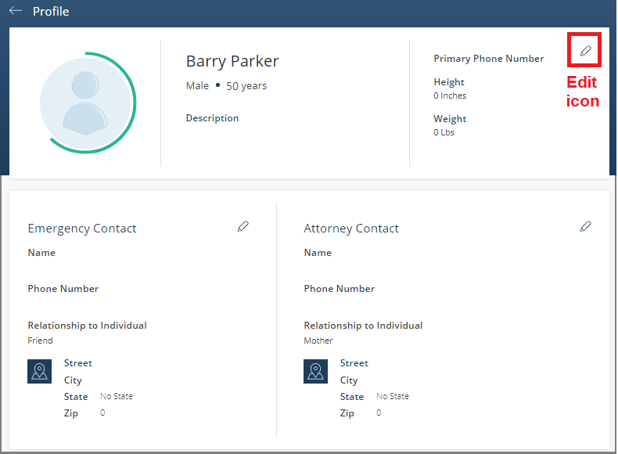

1. Profile page

The **Edit Personal Details** screen opens.

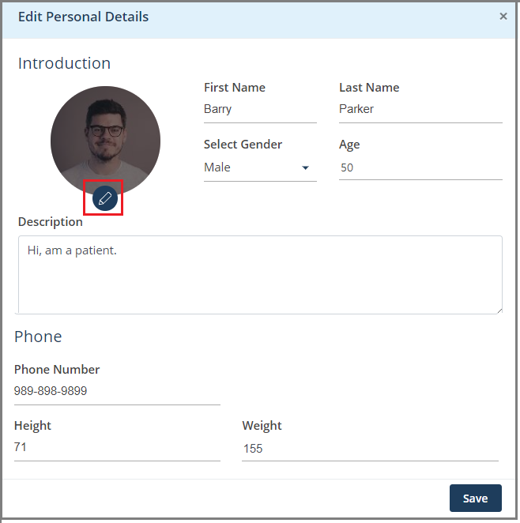

1. Edit Personal Details screen
2. Select the edit icon on the profile logo and upload your picture.
3. Enter the required details on the **Edit Personal Details** page such as name, gender, age, phone number, height (in Inches), and weight (in Lbs). A phone number is necessary without which you cannot save the changes.
4. Select the **Save** button to save the changes that you made to your personal details and to go back to the **Profile** page.
5. Similarly, on the **Profile** page, you can update your emergency contact number and your attorney contact numbers.



1. Profile page

Update your clinical conditions so that the service provider can match you with a caregiver based on your specialized needs, as updated in this section.

1. On the **Profile** page, in the **Clinical Conditions** section, select the edit icon.

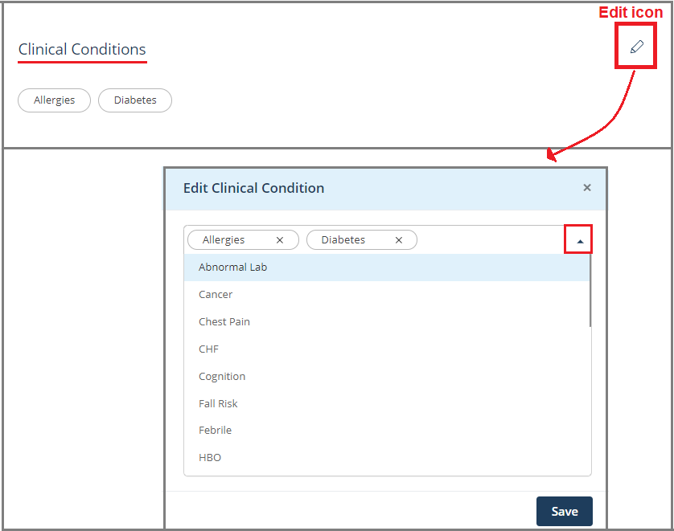

1. Profile page–Clinical Condition and Edit Clinical Condition page
2. Select the drop-down arrow and choose your clinical conditions from the list.
3. Select the **Save** button on the **Edit Clinical Condition** page to update the changes to the **Profile** page.
4. In the **Point of Service** section, select the Edit icon. The **Edit Point of Service** page opens.



1. Edit Point of Service page
2. Enter your address details, which include **Address Type** (May include Home, Office, or Business), **Street** name, **City**, **State** name, and the **Zip** code.
3. Select the **Mark it as Preferred Point of Service** check box to mark the address as your primary address where you would want your services to be offered.
4. Select **Save** to save the changes and go back to the **Profile** page.
5. Similarly, update your secondary address details.
6. In the **Languages Spoken** section on the **Profile** page, enter the languages that you know. This information helps the service provider to match you with a caregiver who can communicate with you in the languages of your choice.
7. In the **My Connections** section on the **Profile** page, you can add details of these members:

* **Individuals:** An individual is the one for whom you are the guardian. You can be a guardian for more than one individual.
* **Guardians:** Your guardian. You, as an individual, can have more than one guardian.

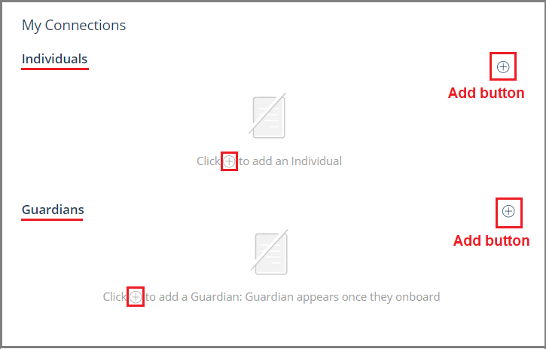

1. Profile page–My Connections section
2. To add an individual that you wish to be the guardian for, select the plus icon (Ꚛ) button for **Individuals**. The **Add an Individual** page opens.
3. Select the **Guardian** profile type and click **Next**.

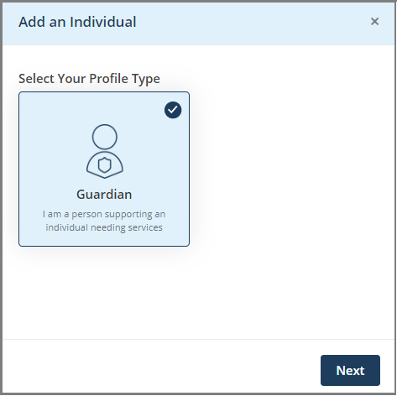

1. Add an Individual page
2. On the next screen, enter these details of your dependent member:

* **First Name**
* **Last Name**
* **Gender**
* **Date of Birth**

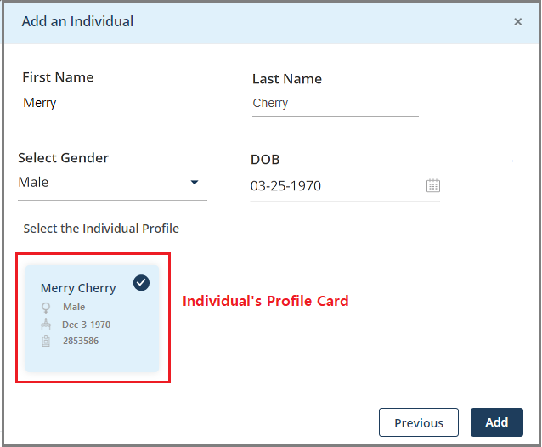

1. Add an individual–enter member details
2. Select the **Search** button to search the individual based on the details that you have entered. The individual’s profile card displays. The individual’s details are fetched from the Coreo Analytics application.
3. Select the individual’s profile card. A tick mark displays indicating that you have selected the card.
4. Select **Add**.
5. Select **Confirm** in the message box to proceed with adding the individual as your dependent. The individual is added to your profile page.

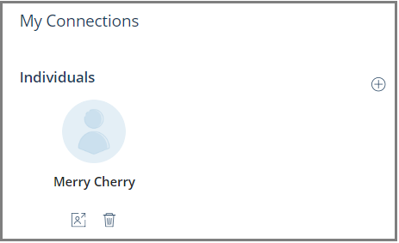

1. Profile page–Individual added to your (patient) profile
2. To add your guardian, select the Add button under **My Connections** on the **Profile** page. The **Add Guardian** page opens.

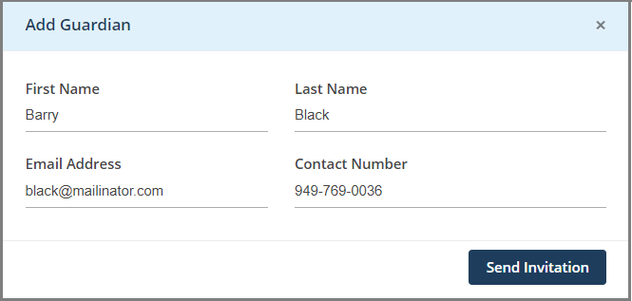

1. Add Guardian page
2. Enter these details: The guardian’s first name, last name, email address, and contact number.
3. Select the **Send Invitation** button to send an email invite to your guardian to create a guardian account in Coreo Home.

Once your guardian accepts the invitation, Coreo Home takes your guardian through a series of steps to onboard them to the Coreo Home-Guardian account.

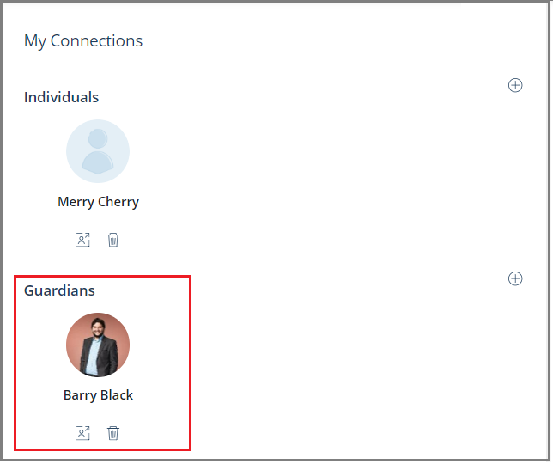

1. Profile page–Guardian added to your (patient) profile

Once your guardian has onboarded successfully, you can view your guardian details on your profile page.

# Set Up Payments

Follow these steps to set up your payment cards to be able to make payments to your service providers:

|  |  |
| --- | --- |
|  | You need not set up payment cards when engaging with an Entity who is facilitating your service request.  However, you cannot engage with individual service providers without saving your payment card. |

s

1. On the side menu, select **Payments** to open the **Payments** screen.



1. Payments screen
2. Select the **Add New Card** button to open the **Add New Card** window.



1. Add New Card window
2. Enter the card number, the CVC/CVV number, and the card expiration date of your payment card.
3. Select **Save** to save the card details.

A message box displays indicating that you have successfully saved the card. You can view the saved card.

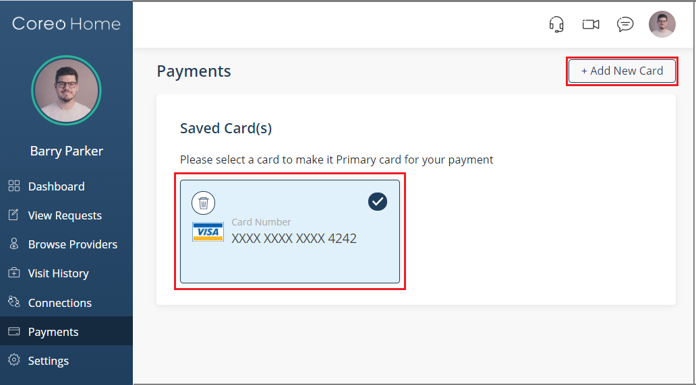

1. Payments-saved card
2. To add multiple payment cards, select the **Add New Card** button, and repeat the process to save another card.

# Individual User Dashboard

Your dashboard is the main screen you see when you sign in to Coreo Home as an existing user.

However, when you sign in for the first time as a new member, Coreo Home takes you to the **Browse Providers** screen. You can navigate to the dashboard from the side menu.



1. Dashboard screen-upon first-time sign in

The dashboard has two sections:

Calendar Panel

Wizard Panel

## Get to Know the Calendar Panel

Use the Calendar Panel to do these tasks:

* Create a new service request using the **New Request** button in this section when you have signed in to Coreo Home as a new member.
* Look through the available service providers by using the **Browse Providers** button.
* If you have created service requests, track your service visits collectively in this section.

Once you create your service requests, the related service visit cards are created, and you can view all your scheduled service visits in one place on the dashboard.

The calendar panel displays the service visit cards in rows, and the visit-view calendar helps you to sort your visits based upon the month and day.

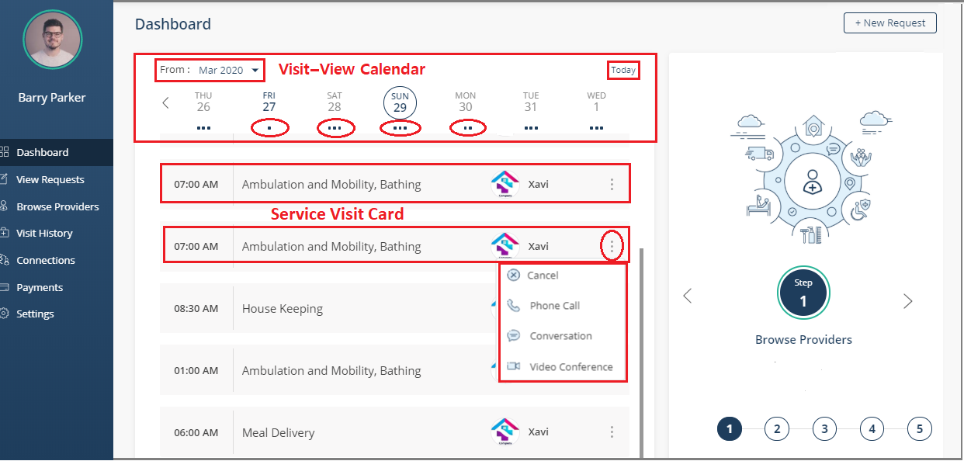

1. Dashboard screen-with service visits
2. Click the **From** arrow and select the month for which you want to view the scheduled visits. The related service visit cards are shown.

The horizontal dots below each date indicates that the visits are scheduled for the day. One dot implies one visit; two dots - two visits, and three dots indicate three or more visits.

1. If required, use the left chevron icon (<) to navigate to the starting days of the month and the right icon (>) to navigate to the later part of the month.
2. Click the **Today** button to view the service visits scheduled for the current day.

Service Visit Card

A service visit card displays the time at which the visit starts, the type of services that you have booked, and the provider’s name.



Click the three vertical dots/ellipses icon next to the service provider’s name to open the drop-down list, and select from the following options:

* **Cancel:** Cancel the scheduled visit.
* **Phone Call:** Make a phone call to the provider.
* **Conversation****:** Have text conversations with other members. You can chat with your service providers, guardians, or your dependent members.
* **Video Conference****:** Video conference with your service providers, guardians, care team, or dependent members.

Coreo Home Mobile Device App for Individual users

Download the Core Home mobile app on your smartphone or tablet and sign in to your user account.

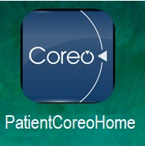

Coreo Home mobile app icon - Individual

The screens in the Coreo Home Web and the Mobile app have the same foundational structure with slight variation in the way you navigate through the app. The variations in the mobile app are summarized here.

The **Dashboard** screen of an Individual in the mobile app is as illustrated:

 

1. Dashboard Figure 26 b. Dashboard with service visits

You can navigate through the app using the bottom tab bar. The bottom tab bar icons are listed below:

* **Dashboard:** The home screen where you can view your scheduled visits and create new requests.
* **Requests:** View your service requests along with their status.
* **Providers:** Browse the service providers.
* **Conversations:** You can chat with your service providers, guardians, or your dependent members.
* **Menu:** Add your guardian or a dependent member in **Connections**, view the fulfilled visits in **View** **History**, video conference with other members, or change the notification settings.

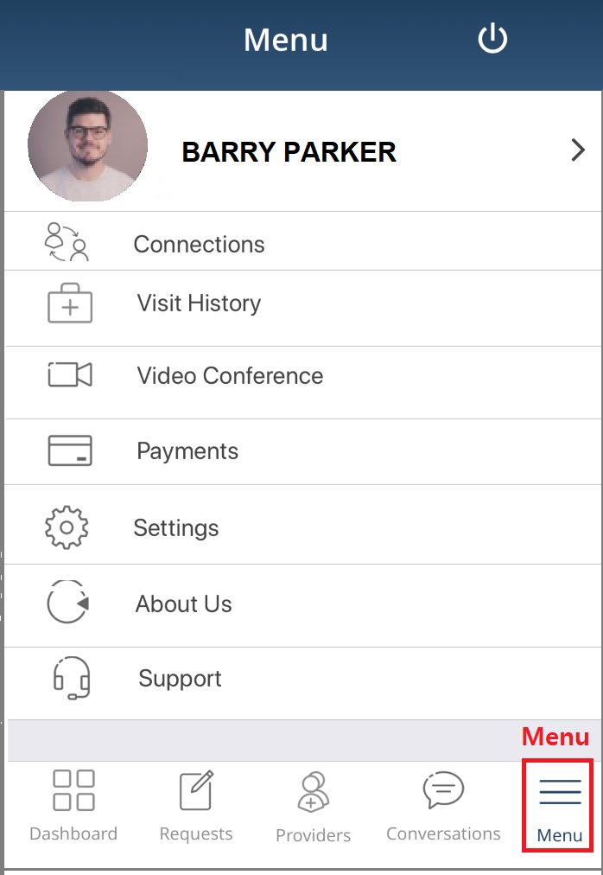

1. Menu screen

## Using the Wizard

The wizard guides you through a sequence of steps to create and post a service request.

**Step 1 – Browse Providers**

**Step 2 – Engage Provider**

**Step 3 – Create Request**

**Step 4 – Visit(s) Schedule**

**Step 5 – Submit Feedback**

When you sign in for the first time, you are on the **Browse Providers** page, which is the first step when creating a new service request. However, when you sign in as an existing user, Coreo Home takes you to the **Dashboard** screen, which is your home screen.

In the Coreo Home mobile app, the wizard panel is placed below the calendar panel on the dashboard, scroll down to access it. In the desktop app, the wizard panel is adjacent to the calendar panel.

## Browse Providers



The user can have the service requests fulfilled by the following two types of service providers:

* Entity User (EU): The EU accepts your service requests, creates a plan based on your request, schedules the visits, and fulfills the visit process.



* Individual Service Provider (ISP): An ISP can fulfill the service request in Coreo Home by scheduling the visit plan, completing the visit process, and processing the payments.

An ISP has the per hour rate and the age displayed on the **Browse** **Providers** screen. Whereas the entity does not have these details displayed.



## Engage Provider



Follow these steps to engage with a service provider:

1. Choose the required service provider on the **Browse Providers** screen. You can engage with either entity or individual service providers.



1. Browse Providers screen
2. Select the **Engage** button to engage with the service provider. The **Select a Service Request to Engage** form opens, if you have any existing open service requests.

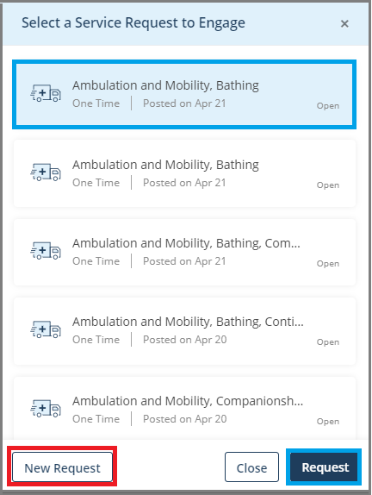

1. Select a Service Request to Engage form

If there are no open service requests, the **Create New Service Request** screen opens.

A service request is in **Open** status when your service provider has not engaged with you and accepted your service request yet.

1. Select an existing open service request and click the **Request** button to engage with the selected provider for the open request. You can view a confirmation message box informing you that you have engaged with the selected service provider for the specified service category.

Or,

1. Select the **New Request** button in the **Select a Service Request to Engage** form to create a new service request.

Note: You can also create a new service request from these places:

|  |  |
| --- | --- |
| * **New Request** button on the header bar |  |
| * **Create New Request** button from the wizard |  |
| * **New Request** button on the **View Request** page |  |

1. The **Create New Service Request** screen opens.



1. Create New Service Request screen
2. Choose the service categories from these tabs:

* **Activities Of Daily Living**
* **Help At Home**
* **Groceries And Nutrition**
* **Transportation**

On selecting each of the above tabs, Coreo Home lists the vendors who offer the related services under each category.

1. Click the service provider’s name, or the profile picture to view the profile details, types of services offered, service location, available time-slots, among others.

You can also open the **Create New Service Request** screen from the wizard in step 3.

## Create and Post a Service Request



Coreo Home takes you through four steps on the **Create New Service Request** screen to hire a service provider.

1. Service
2. Preference
3. Questionnaire
4. Review



1. Create New Service Request screen

Service

1. Select the **Service Category** from the following options:

|  |  |  |  |
| --- | --- | --- | --- |
| **Activities Of Daily Living** | **Help At Home** | **Groceries And Nutrition** | **Transportation** |

**Activities Of Daily Living** is the default service category. Under each of the four service categories, the related service types are listed.



1. Create New Service Request screen–Service page
2. Choose the service types. *For example, you can choose* ***Ambulation and Mobility*** *and* ***Bathing,*** *which**are**two of the service types under the* ***Activities of Daily Living****.*
3. *Similarly, under the* ***Help At Home*** *service category, choose the service types* ***Companionship and Errands****,* ***Food Prep****, and* ***House Keeping****.*
4. Enter the additional information about yourself or your requirements, if needed.
5. Select the **Next** button.

Preference

The **Create** **New Service Request**–Preference page opens.



1. Create New Service Request screen–Preference page
2. Select the schedule type from these two options:

* **One Time:** Use this option to schedule a service for a single date of your choice. You can have a maximum of three slots or visits, **Morning**, **Afternoon**, and **Evening** for a **One Time** schedule type.
* **Recurring:** Use this option to schedule multiple visits at regular intervals until a date of your choice.

Schedule Type–One Time

Under the **Schedule Type**, **One Time** is the default selection.



1. Create New Service Request screen
2. Select the calendar icon to select the preferred date.
3. Select the preferred slot for which you want to receive the services from these options:

* **Morning**
* **Afternoon**
* **Evening**

1. Scroll to the bottom of the screen.
2. Select the location at which you want to receive the service under **Point of Service**.



1. Create New Service Request screen
2. Select the gender preference of the caregiver from these options:

* **Male**
* **Female**
* **No Preference**

1. Select the **Next** button to open the **Questionnaire**.

Schedule Type–Recurring

Under the **Schedule Type**, select the **Recurring** button to schedule multiple visits periodically until the selected date.



1. Create New Service Request–Schedule type-Recurring
2. Select the recurring pattern from one of these two options:

* **Weekly**
* **Monthly**

1. In the **Start** box, select the starting date of the recurrence period that you want to book the service for.
2. Select the end date of the recurrence period from one of these two options:

* **End after**: Your service period ends after the number of occurrences that you have entered here.



* **End by**: Your service ends after the date that you have specified here.



1. Select the preferred slots for which you want to receive the services:



***Example****: You enter 6 occurrences and select 6 slots (Monday – Morning, Afternoon, Evening; Tuesday – Morning; and Thursday – Morning, afternoon). The service visit begins from the start date that you have given, and you would be receiving the visits for the selected slots.*

If you select a lesser number of slots than the number of occurrences, the remaining slots are serviced the following week.

***Example****: You enter 6 occurrences and select only 3 slots (Monday – Morning; Tuesday – Morning; and Wednesday – Morning). The remaining 3 slots are serviced the next week in the same pattern (Monday – Morning; Tuesday – Morning; and Wednesday – Morning).*

Similarly, if you select the **Monthly** option, you shall receive the service for the slots that you select periodically, based on the number of occurrences or the end-by date.

1. Scroll to the bottom of the screen.
2. Select the location at which you want to receive the service under **Point of Service**.
3. Select the gender preference of the caregiver.
4. Select the **Next** button to open the Questionnaire.

Questionnaire

1. Fill in the questionnaire to help the caregiver provide you better service based on the answers that you give in the questionnaire.



1. Create New Service Request screen–Questionnaire
2. Select the **Next** button to open the **Review** screen.

Review

1. Go through the details that you have provided in the previous three stages on the Review page.



1. Create New Service Request–Review
2. If you want to make any changes in your previous selections, select the **Previous** button, and make the required changes.
3. Select the **Post** button to post the service request that you have created.
4. Select the **OK** button to go to the **View Requests** screen.

|  |  |
| --- | --- |
|  | If you choose the service category, **Transportation**, the care team member must approve your request.  You can create and post a service request with the service category, **Transportation**. Still, you cannot see the posted request on the **View Requests** screen unless a care team member approves it.  However, the service requests that you create and post with other categories can be tracked on the **View Requests** screen. |

## Visit(s) Schedule



You can also open the **View Requests** screen by clicking the **Visit(s) Schedule** button in the wizard on the dashboard or from the side menu.

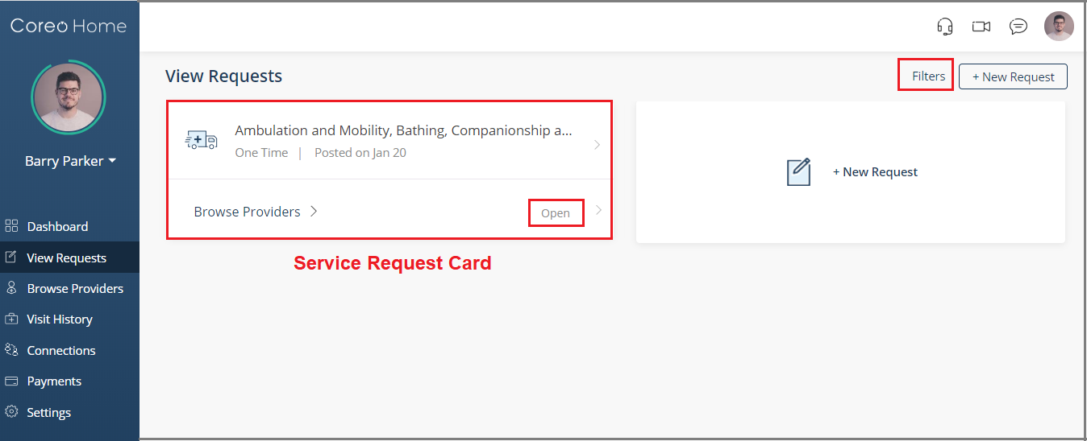

1. View Request screen–status-Open

If needed, use the **Filters** button to locate the service request card, or you can scroll down on the screen to track the required service request card.

Notice that the Service Request (SR) card displays the status **Open** when your service request is not accepted by the service provider, yet. The status changes to **Engaged** when your service provider accepts your service request.

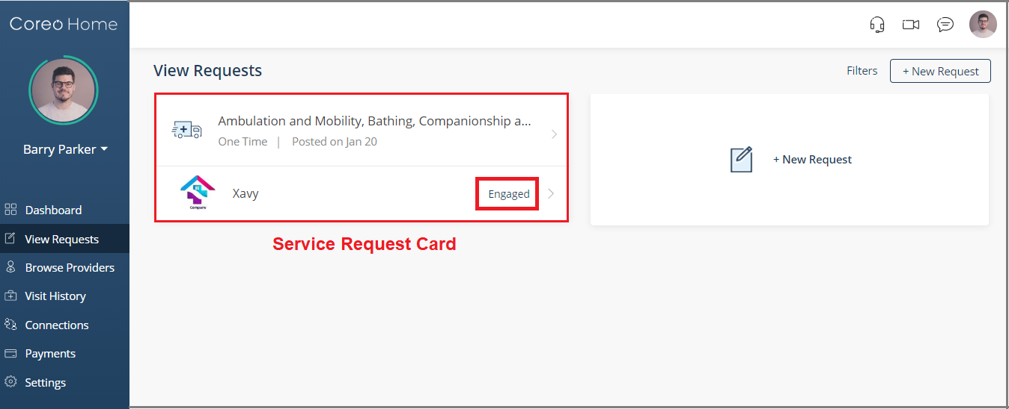

1. View Request screen–status-Engaged

When you create a new service request directly without engaging a specific service provider, the application creates an open request. The status of the service request card is **Open**.

1. Select the SR card to view the details under the **Request** tab, **My** **Plan** tab, and the **Provider** tab.
2. View details such as the service category, service types, schedule and frequency, and the point of service that you had selected for the service visits.



1. Request tab page
2. At any point in time, you have the flexibility of canceling the scheduled visit by selecting the **Cancel Request** button.
3. Select the **My Plan** tab to view the scheduled visits.

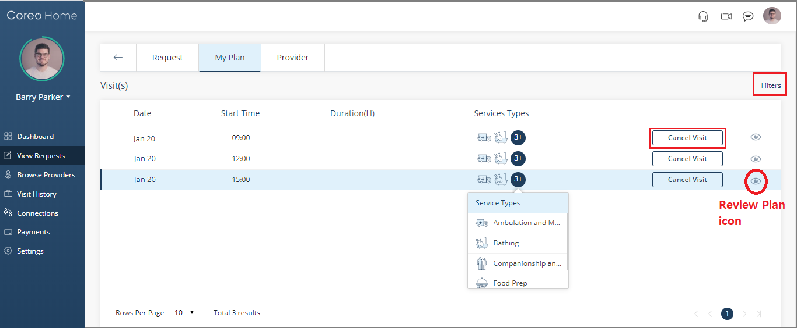

1. My Plan tab page
2. Select the **Filters** buttonto filter the visits based on the visit-date, service categories, and types, or the status of the service visits.
3. On the **Filters** page, select the **Date Range** button to filter the visits based on the visit-date.

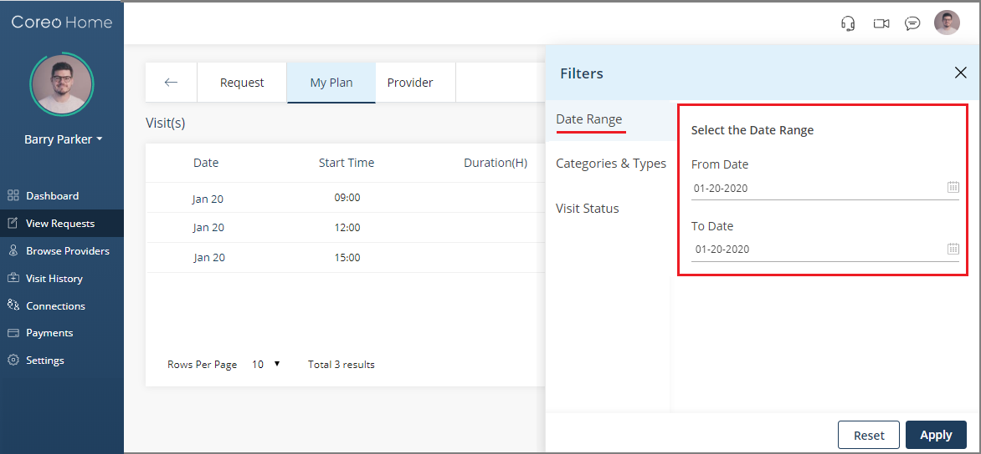

1. Filters page
2. Select the **Visit Status** button to filter the SRs based on these options:

* **Scheduled**
* **In Progress**
* **Completed**
* **Canceled**
* **Payment Pending**
* **Entity Process**

1. Select **Apply** to apply the filter criteria. You can use the **Reset** button to reset the filter selections.
2. On the **My Plan** tab page, the status changes to **In-Progress** when the caregiver has started the service visit, which is tracked by the timer on the **Visit Processing-Tasks** screen.



1. My Plan tab page– visit status-In Progress
2. At any point during the visit, select the **In-progress** button. The **Visit** **Processing** screen opens where you can check the progress of the visit.

When the visit is still in progress, the timer on the **Visit Processing - Tasks** screen records the time the caregiver spends to complete the tasks. Note that when the timer is on, the **Next** button is not available.

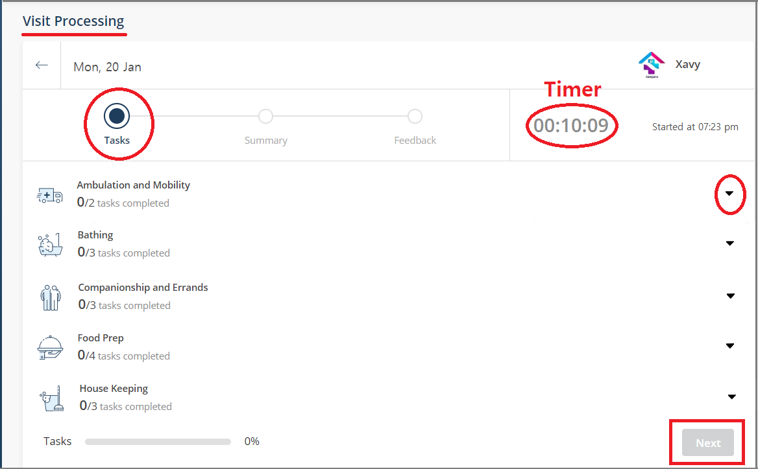

1. Visit Processing–Tasks page
2. You can also view the service types that you had booked for. Click the arrow next to a service type to view the related tasks that the caregiver is supposed to complete.

After completing all the tasks, your caregiver stops the timer, and you can see the timer in your session also being stopped. The chargeable time displays in Hours: Minutes.

1. Select the **Next** button, which is available once the timer stops on the **Visit Processing – Tasks** screen to go to the **Visits Processing - Summary** screen.

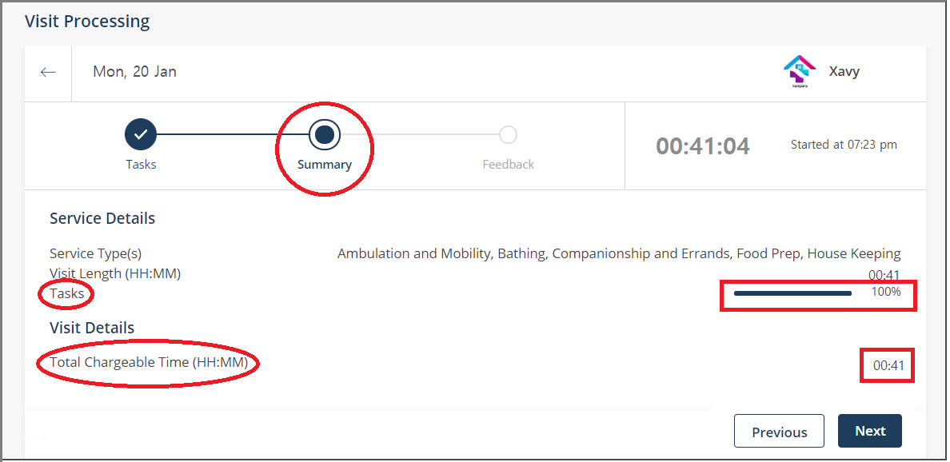

1. Visit Processing–Summary page
2. Review the details of the service visit to check for these points:

* Make sure that the actual time the caregiver has put in is what you are charged for.
* Make sure that the tasks completion bar is 100%.

1. Click **Next** to go to the **Feedback** page. You may also skip this step and choose to fill the feedback form at a later stage on the **Visit Summary** page.

## Submit Feedback

We recommend that you provide the feedback so that the service provider can evaluate the caregiver based on your feedback and provide your better service in the future.

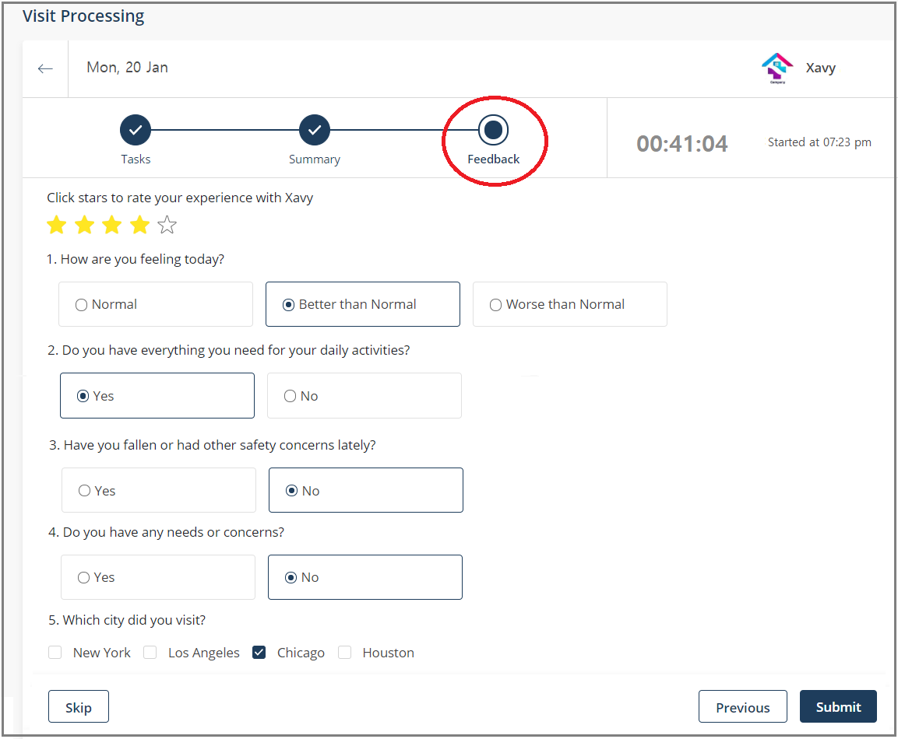

1. Visit Processing–Feedback page
2. Rate your caregiver by giving stars, five stars being the maximum.
3. Answer the feedback questions and select **Submit**.
4. The caregiver completes processing your visit by collecting your digital signature in his/her Coreo Home user account. Review the details on the caregiver’s **Summary** page and put a digital signature in the designated box.
5. In your user account, on the side menu, select **View Requests** and search for the service request card, which was just completed by your caregiver.
6. Click the service request card and go to the **My Plan** tab page.
7. Use **Filters** or scroll down on the page to track the visit card that was processed. You can locate the specific card based upon the visit date.

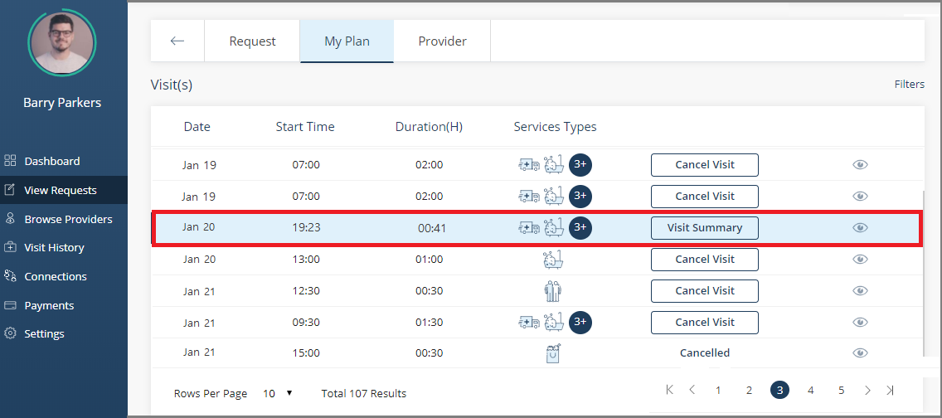

1. My Plan tab page
2. Once the caregiver has completed processing your visit, the status changes to **Visit** **Summary**. Click the **Visit Summary** button to view the visit details on the **Visit Summary** page.

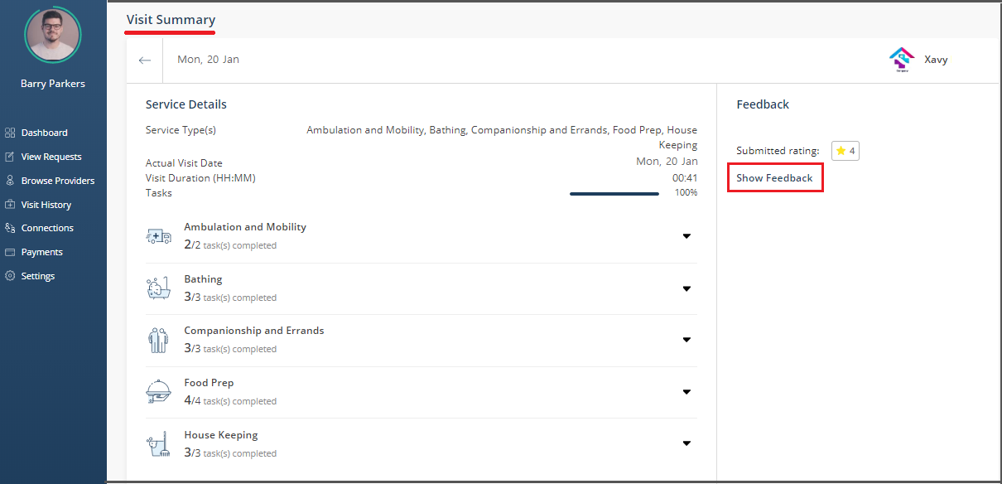

1. Visit Summary

You can also visit the **View Summary** page from the side menu by selecting **Visit History** and then clicking the arrow in the related service visit card.

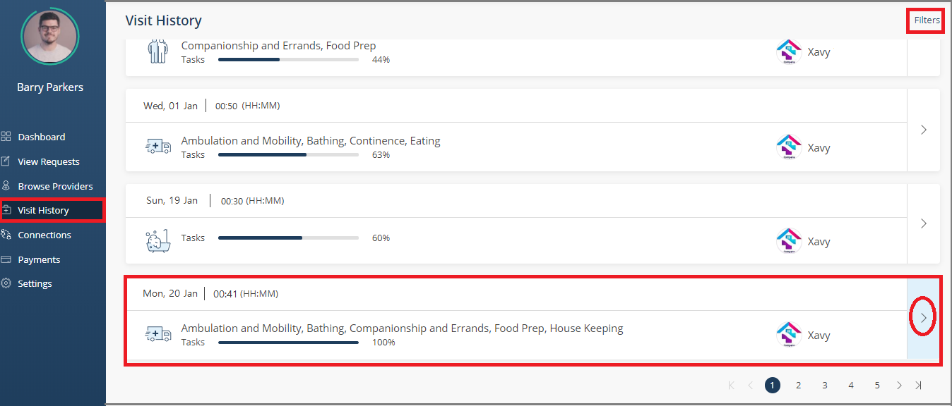

1. Visit History page

You can also submit the feedback of the service visit from the wizard on your dashboard.



1. Go to the dashboard and select the **Submit Feedback** button in the wizard.
2. The **Visit History** page opens. Click the arrow in the related service visit card to open the **Visit Summary** page.

If you have not submitted your feedback yet, you can submit it under the **Feedback** section on the **View Request** page.



However, if you have already submitted the feedback on the **Service Requests** page, you can view the submitted feedback by selecting **Show Feedback**.

# Header Bar

The header bar has the following elements on its right-hand side:



1. **Headset icon**: Access the Coreo Home user help content.
2. **Video icon**: Video conference with your service providers or guardians or dependent members.
3. **Messaging icon**: Have text conversations with other members.
4. **Profile icon**: Edit your profile, or watch the introduction video, or sign out from your account.

## Video Conferencing

Coreo Home supports a video conference call between two or more patient, guardian(s), service provider, or care team members.

Use the video conferencing feature to connect with your caregivers remotely for advice, care, reminders, monitoring, and other communications.

Follow these steps to video conference with your service providers and guardians:

1. On the upper-right corner of the Coreo Home screen, select the video conferencing icon.



1. Video Conferencing icon

The **Video Conference** window opens.



1. Video Conference window
2. Select one or more participants with whom you want to connect through video conference. A green tick mark displays, which helps you identify the selected participants.
3. Select the **Start Video Conference** button.



1. Video Conference screen
2. On the right-hand side of the screen, select the add participant button to include more participants in your video conferencing session, if required.
3. Use the buttons, **Mute Audio**, **Full Screen**, **Leave Conference,** and **End Conference** below the screen to control the session.

## Messaging

Use the messaging feature in Coreo Home to share information quickly by sending and receiving messages with other members.

Follow these steps to have text conversations with your service providers or with your other connections like guardians:

1. On the upper-right corner of the Coreo Home screen, select the conversation icon.



1. Conversation icon
2. Select the **+New Conversation** button.



1. New Conversation window

The **New Conversation** window opens, and your connections and the service providers that you are engaged with displays under the participants with whom you can engage in a conversation.

1. Enter the title of the conversation. You can edit the title any time during an ongoing conversation and select the tick button to save the edits.
2. Select one or more participants with whom you want to converse. A green tick mark displays, which helps you identify the selected participants.
3. Select the **Create Conversation** button. The **My Conversations** page opens.



1. My Conversations page
2. Key in your message in the message box and select the **Send** button. You can add attachments too.
3. On the right-hand side of the screen, select the add participant button to include more participants in your conversation, if required.
4. Next to each participant’s name, you can select the three vertical dots icon to either view the participant’s profile or remove the participant from the conversation.
5. Select the **Leave Conversation** button to quit the conversation at any given point.

## Profile Icon

Use the profile icon on the header bar to do these:

* To edit or view your profile
* To watch the introduction video
* To know more about Navvis
* To sign out from your account



1. Profile icon–drop-down list

# Settings–Configure Notifications

You may be on the move, or away from your desk, Coreo Home mobile notifications keep you informed about the tasks and activities in Coreo Home. You can customize the notification settings according to your preference.

You can use either the Coreo Home mobile app or desktop app to adjust the mobile notification. However, these settings may not apply to your desktop notifications.

1. In your desktop app, on the side menu, select **Settings**. The **My Settings** page opens.



1. My Settings page
2. Choose your notification settings preference, and then select the **Save.**

Notification Settings in Mobile App

On the bottom tab bar, select **Menu**, and then select **Settings** to open the **Notification** **Settings** screen.



1. Notification Settings screen–mobile app
2. Choose your notification settings preference.
3. Select the Manual Syncing - **Sync** button so that you can continue using Coreo Home even if you are in an offline mode, out of mobile network access.
4. Select **Video** to view the introduction video.
5. Select **Save** on the header bar to save the changes.

Section II: Guardian User

# Guardian Onboarding

A guardian is a person supporting one or more individuals needing services.

Follow these steps to create your Coreo Home account as a guardian:

1. Click the Invitation link in the email or message. The link leads you to a screen that guides you through the onboarding process.



1. Choose your profile type
2. On the first onboarding screen, select the **Guardian** option and click **NEXT**.
3. Enter your personal information and your email address on the **Create my user** screen. The email address will serve as the username for your Coreo Home account.



1. Create my User
2. Click the **SEND VERIFICATION LINK** button. A verification link is sent to your email address that you have entered.
3. Go to your mail inbox and click the set password link to set the password for your account.



1. Verification Email
2. On the **Set My Password** screen, enter a new password for your Coreo Home account and reenter the same password in the **Confirm New Password** box.



1. Set My Password screen
2. Choose a security question from the drop-down list.
3. In the **Answer** box, enter the answer. Remember this answer because you have to use it at a later date to reset a forgotten or expired password.
4. Click the **End User License Agreement** link to open the End User License Agreement (EULA) screen.
5. Select the check box after accepting the EULA.
6. Select the **SUBMIT** button to complete the password setting. The application takes you to the **Provide Individual Details** screen.



1. Provide Individual Details
2. Enter the details of your dependent member that you are the guardian for. The details include your dependent’s name, gender, phone number, date of birth, and home address.
3. Click **NEXT**. You navigate to the **Add Guardian** screen.

If you choose to, you can add a guardian. The added guardian can include any individual as his/her dependent member. Adding a guardian is an optional step.

On completing all the steps, you are onboarded successfully.

# Guardian Profile

Edit your (guardian) profile details:

1. On the Coreo Home page, select the profile icon in the upper-right corner on the header bar, and then select the **My Profile** option.

Or, on the side menu, select the name arrow to open the drop-down list, and then select the **Me** option.



1. Coreo Home home page

The **Profile** page of the guardian opens.

1. Select the **Edit** button (pen icon) in the upper-right corner of the **Profile** page.

The **Edit Personal Details** screen opens.



1. Edit Personal Details screen
2. Enter the required details on the **Edit Personal Details** page such as name, gender, age, phone number, height (in Inches), and weight (in Lbs). A phone number is necessary without which you cannot save the changes.
3. Select the **Save** button to save changes and to go back to the **Profile** page.
4. Similarly, on the **Profile** page, you can update your emergency contact number and your attorney contact numbers.
5. In the **My Connections** section, select the plus icon (Ꚛ) next to **Individuals**. The **Add an Individual** page opens.

Or,

1. Select the guardian profile icon on the right side of the header bar and then select the **My Connections** option from the drop-down list.



|  |  |
| --- | --- |
|  | In the guardian account, you access the **My Connections** option from the drop-down list of the profile icon on the header bar. In contrast, in the patient account, you access the **Connections** option from the side menu. |

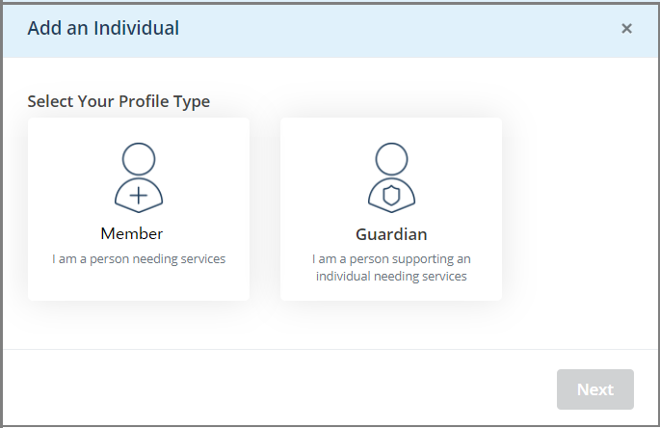

1. Add an Individual page

you can add details of these persons:

* **Guardian**
* **Member**

## Guardian–Be a Guardian to the Individual that You Add

You can be a guardian for more than one individual, and so can add one or more individuals that you want to become the guardian for.

Follow these steps to add another individual and become their guardian:

1. Select the **Guardian** profile type on the **Add an Individual** page.

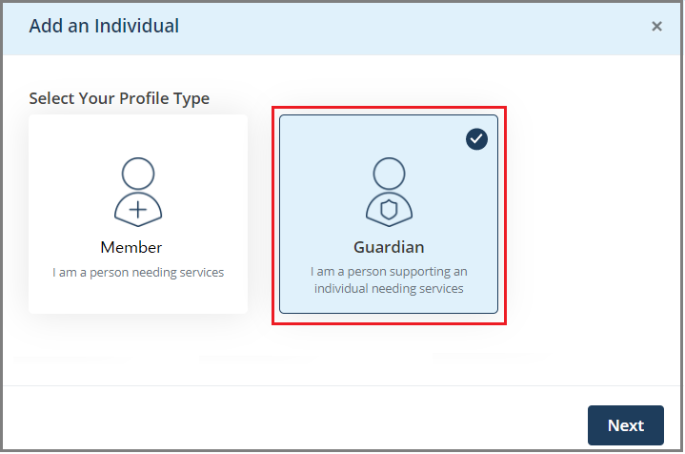

1. Add an Individual page–Guardian profile type
2. Select **Next** to navigate to the next screen.

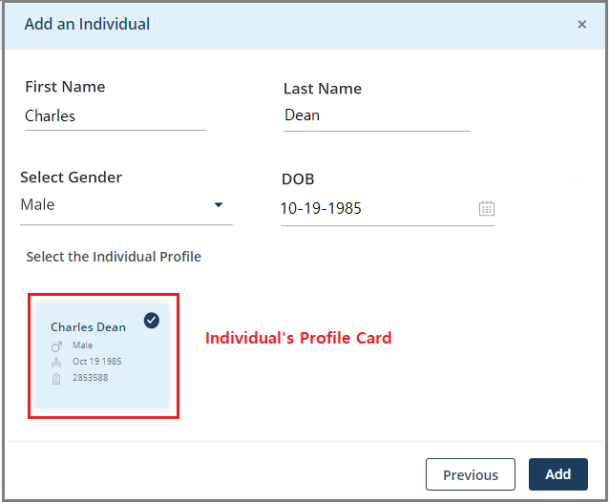

1. Add an Individual– enter member details
2. Enter these details of your dependent member:

* **First Name**
* **Last Name**
* **Gender**
* **Date of Birth**

1. Select the **Search** button to search the individual based on the details that you have entered. The individual’s profile card displays. The individual’s details are fetched from the Coreo Analytics application.
2. Select the individual’s profile card. A tick mark displays indicating that you have selected the card.
3. Select **Add**.
4. Select **Confirm** in the message box to proceed with adding the individual as your dependent. The individual is added to your profile page.

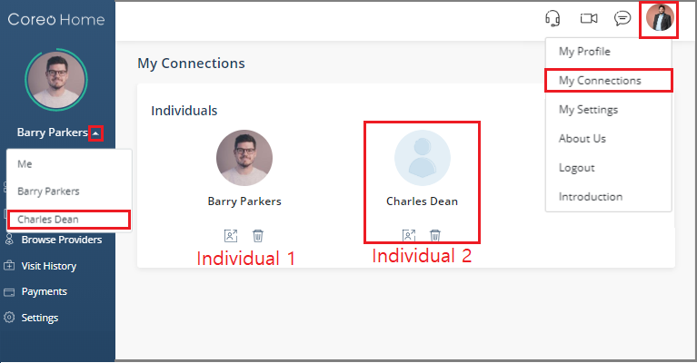

1. My Connections section
2. On the side menu, select the name arrow to view the individual that you just added.

On the Coreo Home mobile-app screen, the name arrow is located on the right-hand side of the screen.

 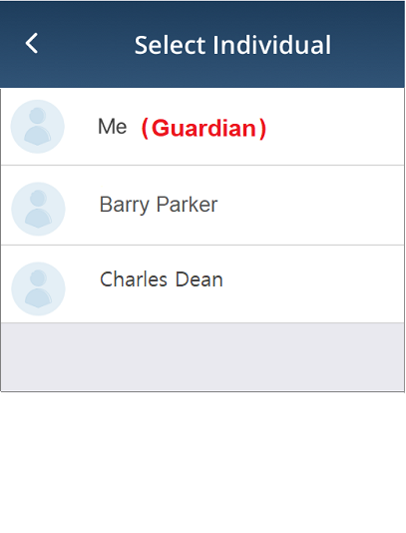

1. Guardian Menu screen Figure b. Select Individual screen

Also, refer to the Coreo Home App in Mobile Devices topic in this user guide for more information on the mobile app screens.

## Member–You are the Member Needing Services

Select the **Member** profile type if you (guardian) want to become an individual who would need services. The guardian, who is also a patient(individual), is referred to as an Individual-Guardian. Your guardian account behaves similarly to an individual user’s account.

1. Select the **Member** profile type and click **Next**.

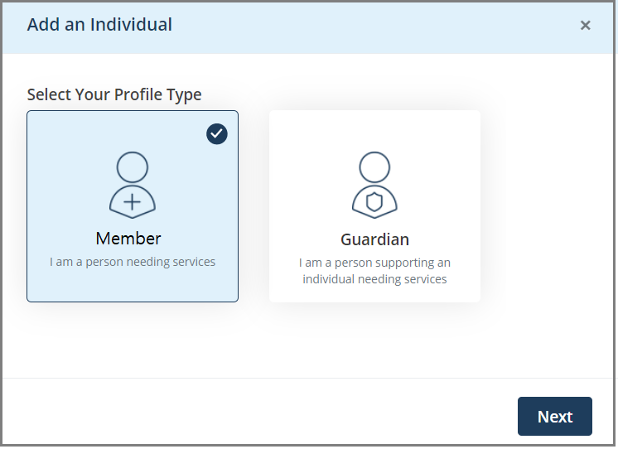

1. add a member
2. On the next screen, enter these details of your dependent member:

* **First Name**
* **Last Name**
* **Gender**
* **Date of Birth**

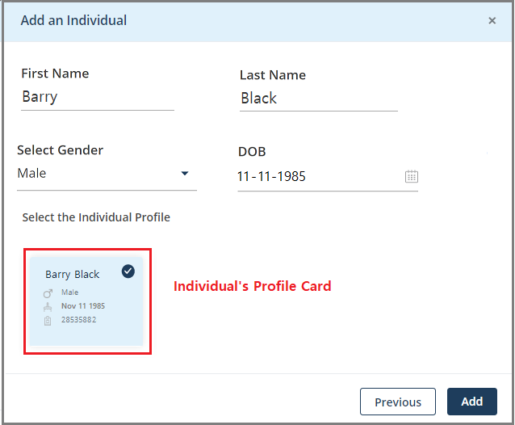

1. Add an individual–enter member details
2. Select the **Search** button to search the individual based on the details that you have entered. The individual’s profile card displays. The individual’s details are fetched from the Coreo Analytics application.
3. Select the individual’s profile card. A tick mark displays indicating that you have selected the card, and then select **Add**.
4. Select **Confirm** in the message box to proceed with you being added as an individual.

Your guardian account behaves similarly to an individual user’s account.

# Acting on Behalf of a Dependent Member

As a guardian, when you sign in to your account, you have access to your dependent member’s account.

On behalf of your dependent, you can do the following changes in your dependent’s Coreo Home patient account.

* Edit the profile details of your dependent member
* Set up payments
* Create and post service-requests
* View requests
* Change settings

Accounts of Inactive and Deceased Dependents

Individuals are flagged as **Inactive** due to multiple reasons. The primary reasons are when the member doesn’t meet the eligibility criteria of the health plan or when the contract has expired.

If your dependent member is an inactive patient, Coreo Home restricts full user access to such accounts.

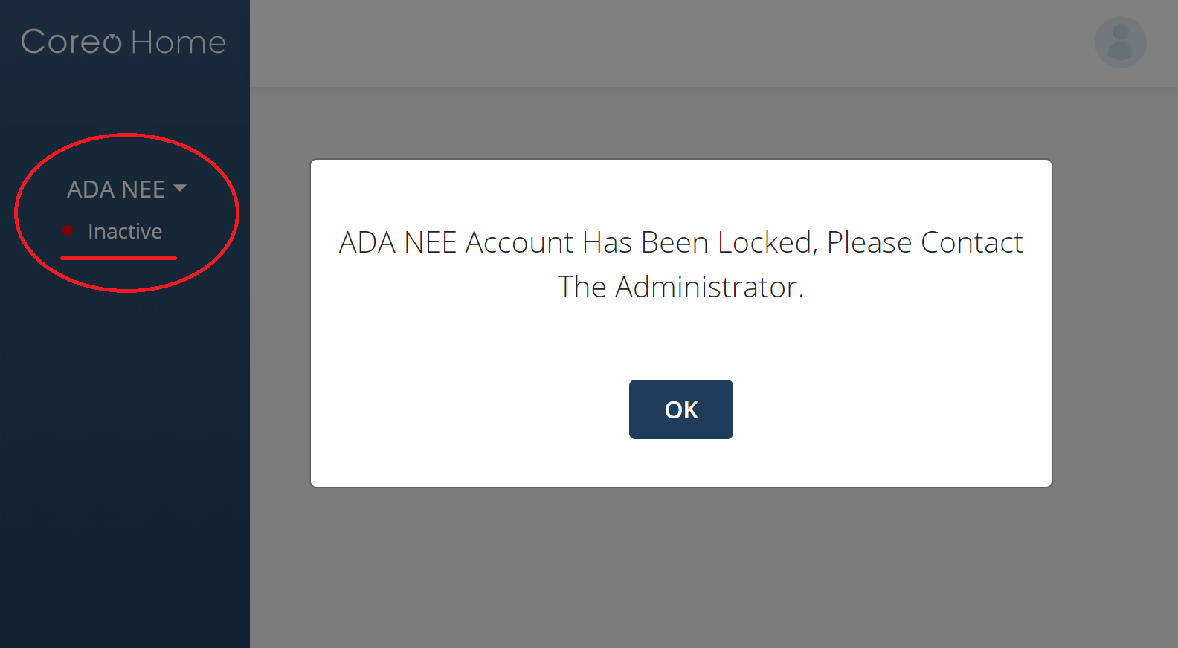

1. Inactive dependent member’s account

When you select the inactive dependent's name from the profile drop-down arrow on the side menu, you can view that the member is flagged as **Inactive**. The application displays a message box stating that the individual’s account has been locked, and you must contact the administrator to unlock the account.

Similarly, in the case of a deceased dependent, you just have the view-access to their account and cannot operate it.

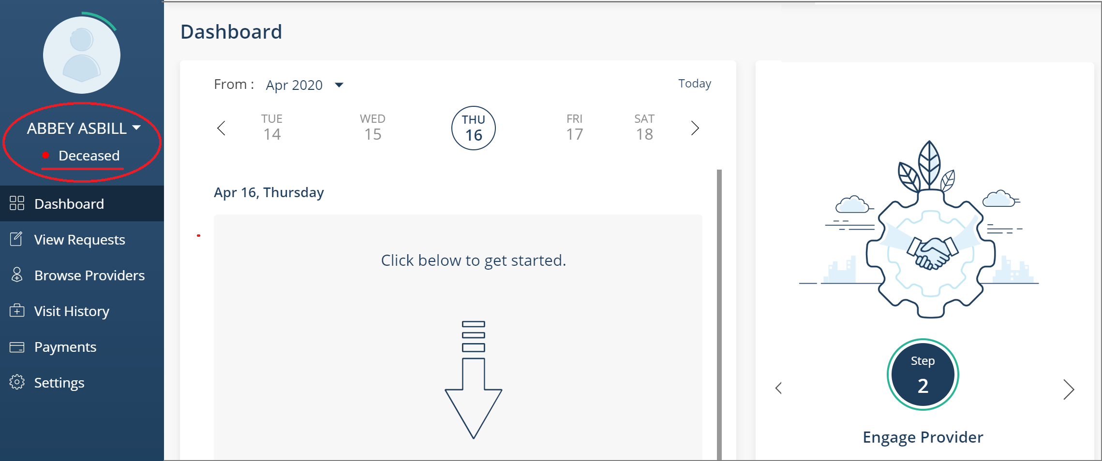

1. deceased dependent member’s account

When you select the deceased dependent's name from the profile drop-down arrow on the side menu, you can view that the member is flagged as **Deceased**.

Section III: Entity User

# Entity User Onboarding

To help you get started with the Coreo Home application, the Navvis administrator sends a Set Password email to your registered email address or a text message to your registered phone number.

Follow these steps to create your Coreo Home account as an entity user:

1. Click the Set Password link in the email or message. The link leads you to the home screen of Coreo Home.

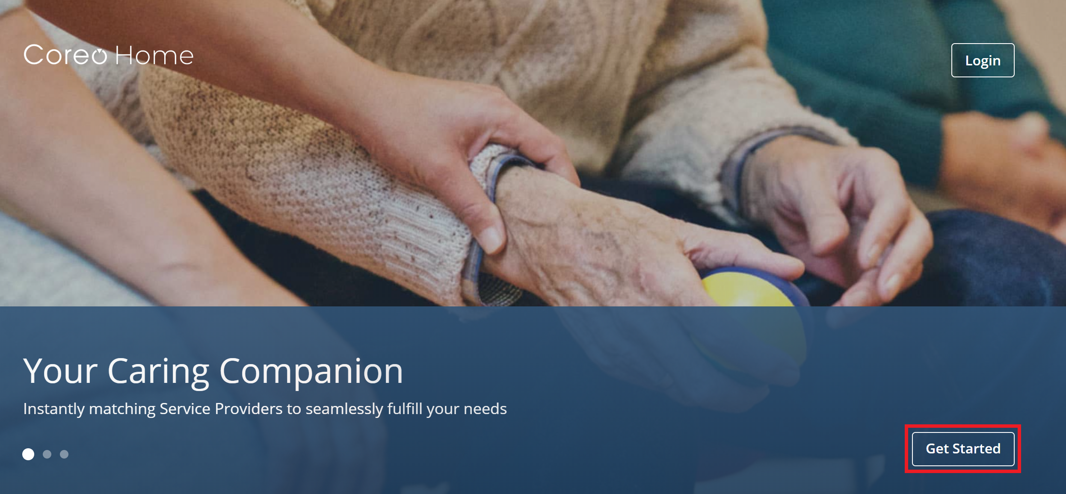

1. home screen
2. Click the **Get Started** button. The **Verify My Email Address** screen opens and guides you through the rest of the onboarding process.

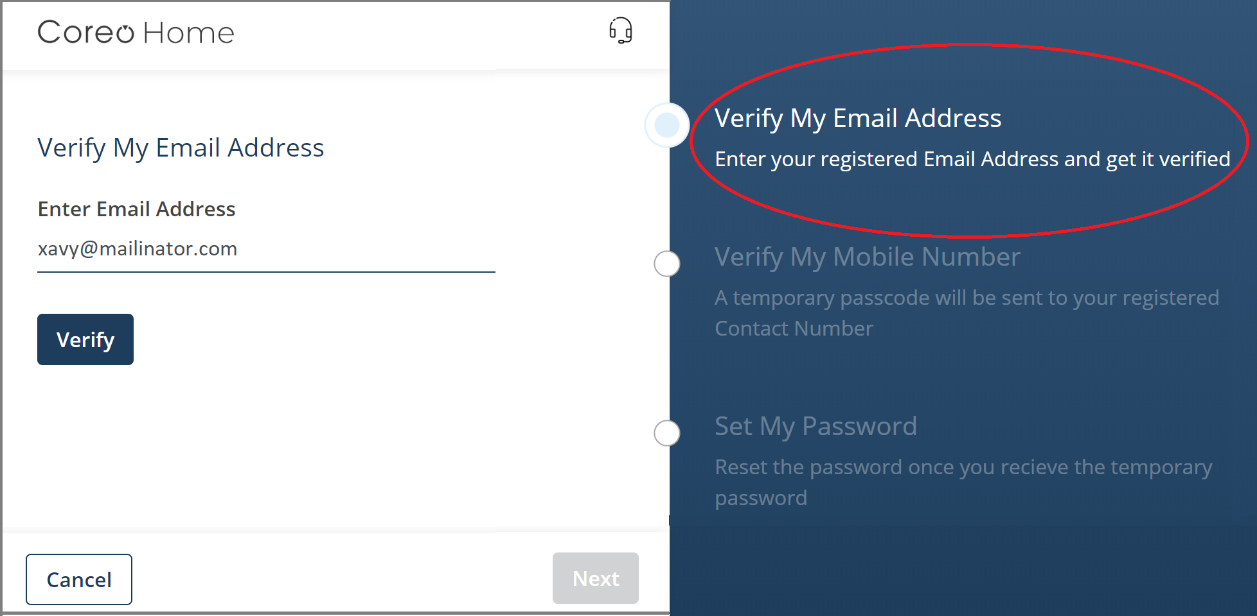

1. Verify My Email Address screen
2. Enter your email address and click **Verify.** Coreo Home verifies the email address that you just entered with the following message:

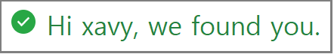

1. Click **Next** to open the **Verify My Mobile Number** screen.
2. Click the **Send Temporary Password** button to have a temporary password sent to your registered phone number for your account.

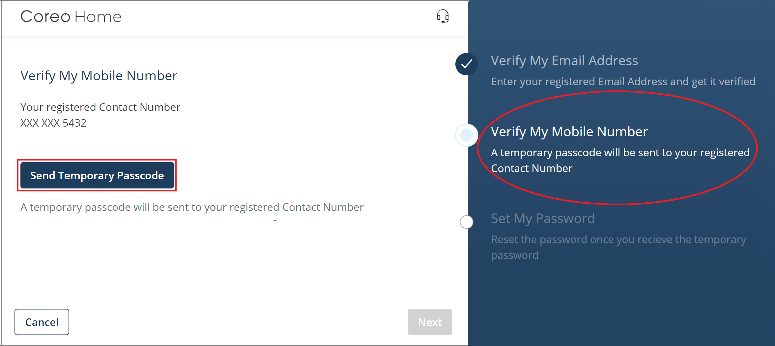

1. Verify My Mobile Number screen
2. Enter the temporary password sent to your phone number and click **Next**.

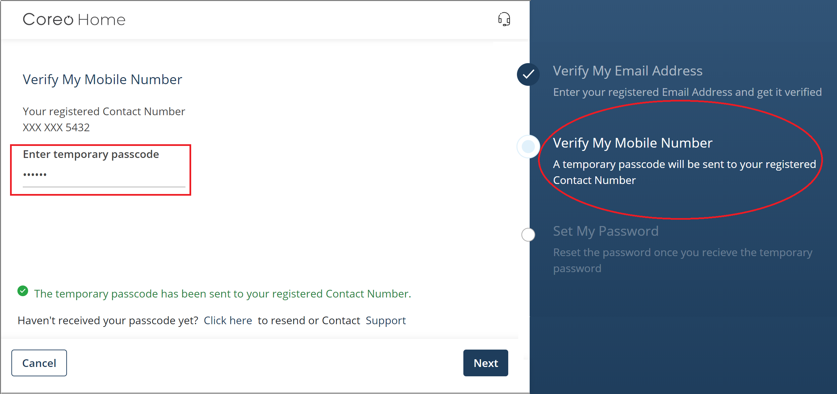

1. Verify My Mobile Number screen
2. On the **Set My Password** screen, enter a new password for your Coreo Home account.

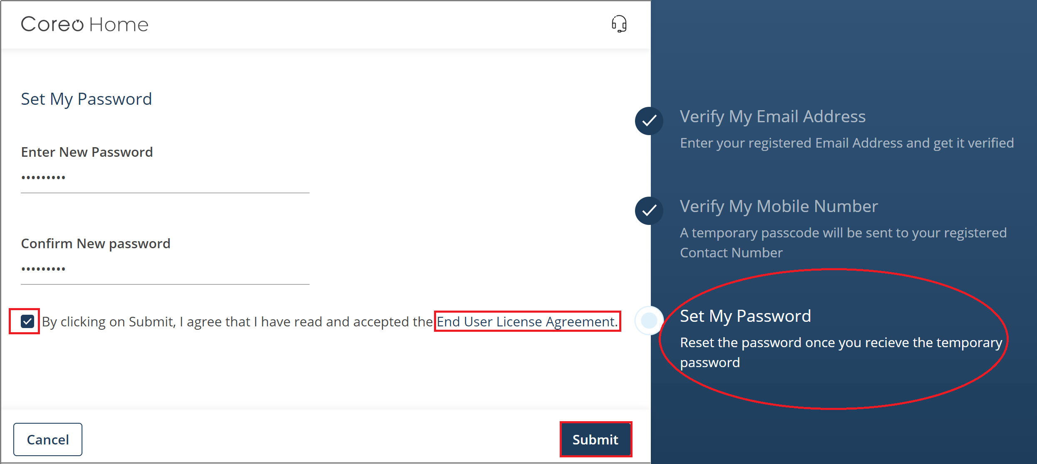

1. Set My Password screen
2. Reenter the same password in the **Confirm New Password** box.
3. Choose a security question from the drop-down list.
4. In the **Answer** box, enter the answer. Remember this answer because you have to use it at a later date to reset a forgotten or expired password.
5. Click the **End User License Agreement** link to open the End User License Agreement (EULA) screen.
6. On the **Set My Password** screen, select the check box after accepting the EULA.



1. Select the **SUBMIT** button to complete the onboarding process, and you can view the message that you are onboarded successfully.



1. Click the **Continue** button to proceed with the sign in.
2. On the Welcome screen, enter your registered email address, which would be your user name, and enter the password.
3. Select **Login** to sign in to your Coreo Home account.

# Entity User Profile

Help your customers (patients) and the service providers who would associate with your organization to learn more about you by completing your profile.

Add the following to your profile: Organization-name details, address details, type of services that you offer, skills and experience in handling various clinical conditions and home care services, geographical locations where your services are available, spoken languages, and any relevant certifications and licenses that your company holds.

Be sure to include your business profile image or your organization logo. The profile image helps your customers know who you are. Preferably, upload a clear and recent image.

## Update or Review Your Profile

You can update or edit your profile details:

1. Select the profile logo on the side menu or the upper-right corner of the header bar.



1. entity Dashboard
2. The **Profile** page opens. Select the **Edit** button (pen icon) in the upper-right corner of the **Profile** page.
3. The **Edit Entity Details** screen opens.
4. Select the edit icon on the profile logo and upload the business profile image or your organization logo.
5. Add the following to your profile; the name of your organization in **Entity Name**, the Web address of the company in **URL**, and the number of years of experience in **Years in Business**,
6. Include a brief description of your organization in the **Description** box.
7. Enter the address of your organization, your phone number, and save the changes.
8. On the **Profile** page, click the **Edit** button in the **Services Offered** section.



1. Profile page–Services Offered
2. Select the service types that you offer in the **Edit Services Offered** screen.

The **Activities of Daily Living**, **Help at Home**, **Groceries** **and** **Nutrition**,and **Transportation** are the service categories. The service types are grouped under a service category.

1. Similarly, on the **Profile** page, update the skills and experience that your organization has in handling various clinical conditions and home care services.
2. In the **Service Areas** section, include one or more geographical locations where you offer services.
3. Under **Availability**, select the days and the period-slots in which you can provide service to your customers.



1. Profile page–Availability
2. In the **Languages Spoken** section on the **Profile** page, enter the languages that you and your affiliated service providers can converse in. This information helps the customer when choosing the service providers.
3. On the **Profile** page, include any relevant certifications and licenses that your company holds.

# Dashboard

Your dashboard is the main screen you see when you sign in to Coreo Home. View the summary under the following tabs:

|  |  |  |  |
| --- | --- | --- | --- |
| **Individuals** | **Service Providers** | **Service Requests** | **Service Visits** |

## Individuals Tab

The **Individuals** tab has three subtabs:

* **Individuals in Total in the Population**
* **Individual with Feedback Alerts**
* **Individuals with Visits in the Period**

Individuals in Total in the Population

The **Individuals in Total in the Population** subtab shows the total number of individuals (patients) who are engaged with your organization.



1. Individuals tab–Individuals in the Total Population subtab

Based on the subtab that you select, the details of the individuals, including individual’s name, gender, age, name of the contract, provider’s name, individual’s cohort, account status displays.

You can use the Search button to search the records in the lower pane of the window based upon the individual’s name that you enter in the Search box.

Similarly, you can use **Filters** to display only those records based on the filter criteria such as gender, contract name, age of the individual, and clinical conditions.

Each individual’s details are displayed in a row with an **Action** button towards the end of the row.

Processing the Visit on Behalf of the Entity Service Provider

Click the **Action** button to open the **My Plan** tab page and the **My Patient** tab page.

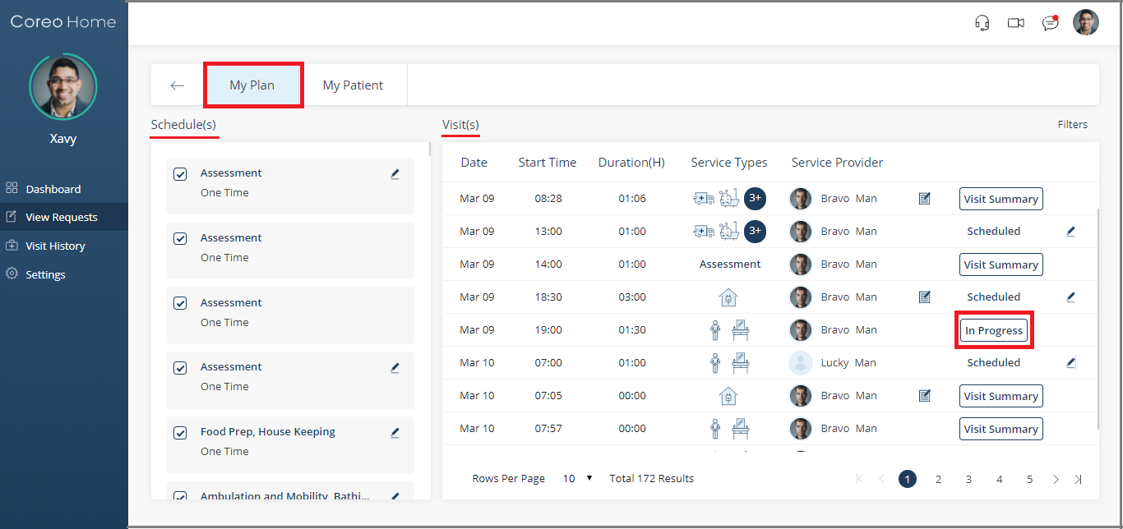

1. My Plan tab page

View the individual’s visit details on the **My Plan** tab such as the visit date, visit start-time, duration of the visit in hours, service types, the service provider who is assigned to the visit, and the visit status.

You can process a visit in Coreo Home on behalf of the service provider if the visit is in the **In Progress** status.

Select an in-progress visit that you want to complete the process for, and then select the **In Progress** button.

The **Visit Processing** screen opens. You can complete the visit-process on behalf of the service provider.

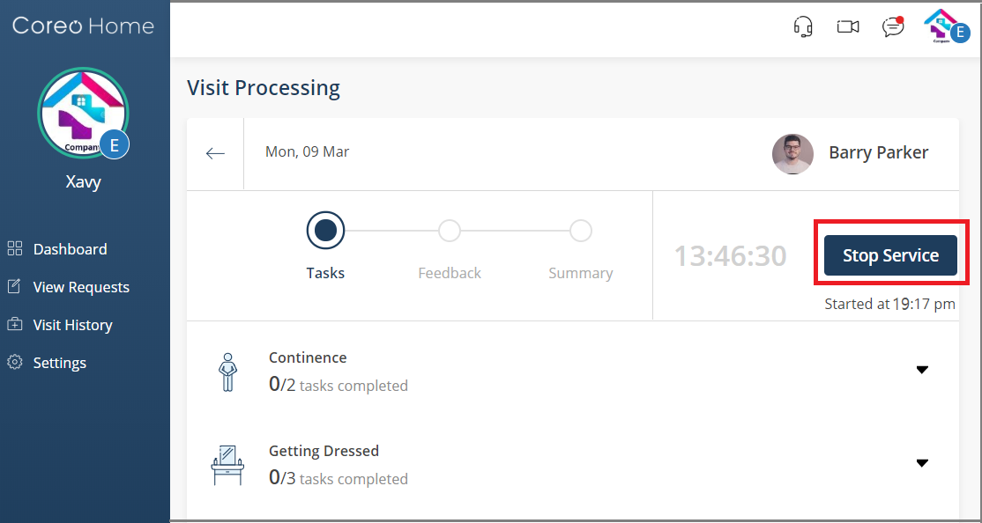

1. Visit Processing screen

For information on how to process the visit, refer to the Start the Visit Process topic in this User Guide under the Entity Service Provider section.

Individual with Feedback Alerts

The **Individual with Feedback Alerts** subtab shows the total number of individuals who have received feedback alerts from their service providers.

The **Alert(s)** box displays the number of feedback alerts of an individual given by the service provider after completing the service visits.

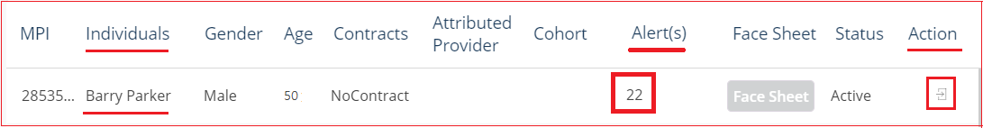

Use the **Action** button to open the **Feedback Alerts** window. Select the visit for which you want to view the feedback and select the **Action** button.

The **Visit** **Summary** screen opens, and then click **Show Feedback** on the right-hand side of the screen to view the feedback submitted by the service provider about the individual.

Individuals with Visits in the Period

The **Individuals with Visits in the Period** subtab shows the total number of individuals who have their visits scheduled from their service providers during a specified period.

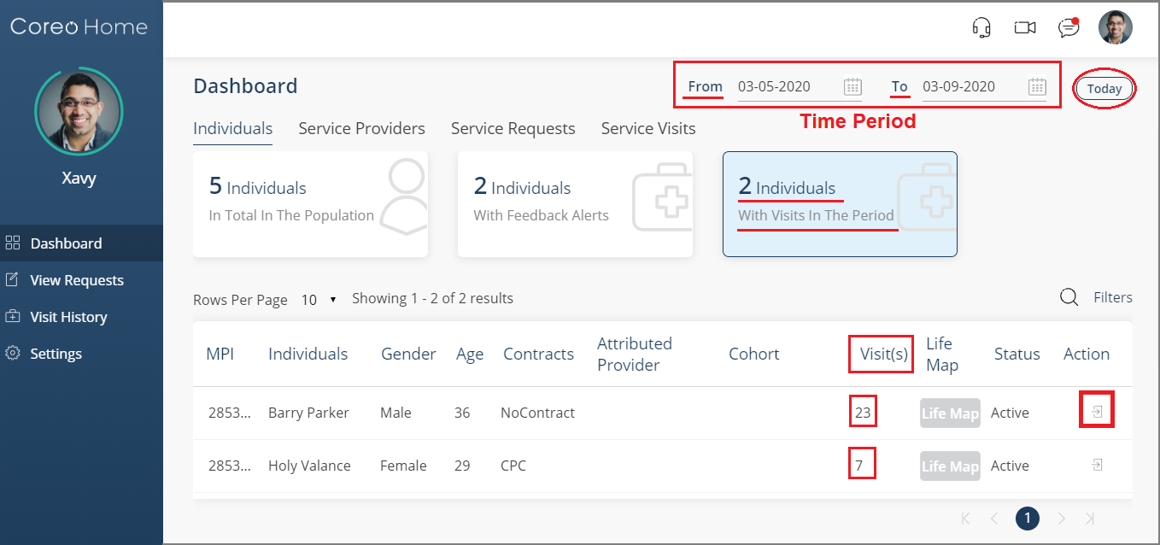

1. Individuals tab–Individuals With Visits in the Period subtab

Select the **From** date and the **To** date of the period that you want to view the visit details for. Or, select the **Today** button to view the visit details of the individuals for the current date.

The total number of service visits for each patient displays in the **Visit(s)** column. Click the **Action** button to view the individual’s visit details on the **My Plan** tab.

## Service Providers Tab

The **Service Providers** tab has five subtabs:

* **Providers in Total in the Population**
* **Providers with Feedback Alerts**
* **Providers with Visits in The Period**
* **Providers with Low Ratings**
* **Providers with Low Task Completion**

Providers in Total in the Population

The **Providers in Total in the Population** subtab shows the total number of service providers who are affiliated with your entity.



1. Service Providers tab–Providers in Total in the Population subtab

Based upon the subtab that you select, the details of the service providers, including the provider’s name, contact number, gender, and their ratings are shown.

You can use the Search icon to search the records in the lower pane of the window based upon the service provider’s name that you enter in the Search box.

Similarly, you can use **Filters** to display only those service provider records based upon the filter criteria - gender and ratings.

To view the service provider’s profile, use the **Actions** button provided in each row.

Providers with Feedback Alerts

The **Providers with Feedback Alerts** subtabshows the total number of service providers who have received feedback alerts from their customers.This is the count of the service providers during whose visits the customers have given feedback alerts.

Select the **From** date and the **To** date of the period during which the service providers have received the feedback alerts.

Or, select the **Today** button to view the service providers who received the feedback alerts for the current date.



1. Service Providers tab–Providers with Feedback Alerts subtab

The **Alert(s)** box displays the total number of feedback alerts given by the individuals to the service providers after completing the service visits.

Click the **Actions** button to open the **Feedback Alerts** window. Select the visit for which you want to view the feedback given by the individual, and then select the **Action** button.

The **Visit** **Summary** screen opens. Click **Show Feedback** on the right-hand side of the screen to view the feedback submitted by the individual.

Providers with Visits in the Period

The **Providers with Visits in The Period** subtab shows the total number of service providers who have their visits scheduled during the specified period.



1. Service Providers tab–Providers with Visits in the Period

Select the **From** date and the **To** date of the period for which you want to view the visit details. Or, select the **Today** button to view the visit details for the current date.

The total number of service visits of each service provider displays in the **Visit(s)** column for that period.

Providers with Low Ratings

The **Providers with Low Ratings** subtab shows the total number of service providers who have been rated 3 stars or less by their customers.



You can view the details, including the name and contact number of the service providers who have low ratings.

To view the service provider’s profile, click the **Actions** icon button.

Providers with Low Task Completion

The **Providers with Low Task Completion** subtab shows the total number of service providers who have low task completion percentage.



When fulfilling the visits, the service provider has to complete all the tasks at the customer’s location based upon the service types assigned to them. If the service provider leaves any task incomplete, you, as an entity user, can view the details of such service providers under this subtab.

*For example, under the service types,* ***Ambulation and Mobility****, and* ***Meal Delivery****, there are 2 tasks each. If the service provider completes only one task out of the total four tasks, the task percentage completion would be 25%, and the provider would be placed under the low task completion category.*



1. task completion list–Visit Summary screen

## Service Requests Tab

The Service Requests tab has three subtabs:

* **Requests In Total In The Population**
* **Requests With Open Status**
* **Requests Cancelled In The Period**

Requests in Total in The Population

You can view the total number of service requests posted by all the available customers/patients in Coreo Home. Request in total in the population includes service requests in **Open**, **Engaged,** and **Cancelled** status.

Select the **From** date and the **To** date to view the service requests posted by the customers for a specified period. Or, select **Today** to view the service requests posted for the current date.

The details of the service request including, service request-id, service category, service type, the customer’s name, and the status are shown.



1. Requests In Total In The Population subtab

Click the **Actions** button icon.

You can view the request details under the **Request** tab, the service request plan under the **My** **Plan** tab, and the patient details under **My** **Patients**.



1. Requests tab page

For an open service request, use the **Engage** button to accept the request of the patient, and create a plan for the service request.

Requests with Open Status

View the total number of service requests in **Open** status only.

You can display the records for a specified period, or filter the rows based on the filter criteria. You can also search the records by entering an individual’s name.

Also, you can view the details of the service requests.



1. Requests With Open Status

Click the **Actions** button icon in a service request row to view the request details, the service request plan, and the patient details. You can accept the request of the patient (customer) by using the **Engage** button and create a plan for the service request.

Requests Cancelled in the Period

View the total number of service requests canceled by the patient during a selected period, and the details of those service requests.



1. Requests With Cancelled Status

Click the **Actions** button icon to know more about the canceled service request.

## Service Visits Tab

The **Service Visits** tab has four subtabs

Visits in Total in the Population

View the total number of service visits of all the customers with the related service providers. The **Visits in Total in the Population** count includes visits that are in **Scheduled**, **In-progress**, **Completed**, **Cancelled**, and **Over-due** status.

You can display the records for a specific period, or filter the rows based on the filter criteria. You can also search the records by entering the individual’s name or the service provider’s name.

Use the **Actions** button icon of each row to learn more about the visit.

Visits Overdue in the Period

View the total number of service visits that are overdue for a specified period. Use the **Actions** button icon of each row for more details about the visit.

Visits with Low Task Completion

View the total number of service visits with low task completion percentage. Use the **Actions** button icon of each row for more details about the visit.

Visits Cancelled in The Period

View the total number of canceled visits for a specified period. Use the **Actions** button icon of each row for more details about the visit.

# Video Conferencing, Messaging, and Settings

Refer to the Video Conferencing and Messaging topics in this user guide for information on how to initiate a video call and a conversation with the other members.

One or more organizations represent an entity, and the representative organizations have the same identity as that of an entity. For example, an entity, Meals on Wheels (MW), is represented by organizations such as MW1, MW2, and MW3.

When a patient initiates a video call with an entity, the patient can view them as different organizations representing the entity, that is, the patient can video call with MW1, MW2, MW3 separately.

However, when the patient initiates a conversation through messaging, the patient can view just the entity as a single (MW) unit, and not the different organizations separately. The patient can just view the entity as MW regardless of whether its MW1, MW2, or MW3 at the other end.

Refer to the Settings topic for information on how to configure notification settings for your mobile phones.

# Engaging with a Patient

1. On the side menu, select **View Requests** to open the **View Requests** page. The page lists all the service request cards which are in different status, **All**, **Open**, **Engaged**, **Not** **Hired**, **Closed**, and **Cancelled**.
2. You can use the **Filters** button to filter the service request cards based upon these criteria:

* **Service Categories & Types**
* **Service Areas**
* **Date Range**
* **Status**

1. To engage a service provider with the patient, select the patient’s service request card with the **Open** status. A service request card with **Open** status indicates that a service provider is yet to be assigned to the patient.



1. View Requests screen

The **Request** tab page opens on opening the service request card.



1. Request tab page
2. Review the service request details and select the **Engage** button to engage with the patient. Select **Yes** in the confirmation message box.

Next, assign a service provider to the patient:

1. Go to the **My Plan** tab to create a plan based upon the patient's service request.



1. My Plan tab page
2. Click the **Add New Schedule** button to open the **Add New Schedule** page. The page helps you to create a new schedule for the service request that you are engaged in.
3. Choose the schedule type from these options:

* **Assessment**
* **Standard**

Schedule Type–Assessment

Schedule an assessment-visit of the care member/service provider to the patient’s home based upon the service request:

1. Select the schedule type, **Assessment**.



1. Add New Schedule–Assessment
2. In the **Schedule** section, enter the date that you want to schedule the assessment on in **Start Date**.
3. Choose the start time and the duration of the visit. The end time displays based upon the duration that you enter.
4. In the **Point of Service** section, select the point of service. The point of service is the location that falls in your service area, where your organization provides services.
5. Assign a service provider to complete the assessment visit to the patient’s home. You can assign only those service providers who are affiliated with your entity.
6. If required, you can enter a note in the **Assign Other Service Provider** box to have another service provider fulfill the visit.
7. Click **Save** to save the entries. A plan is created on the **My Plan** tab under **Upcoming Visit(s**), and the corresponding schedule type is displayed under **Schedule(s**).

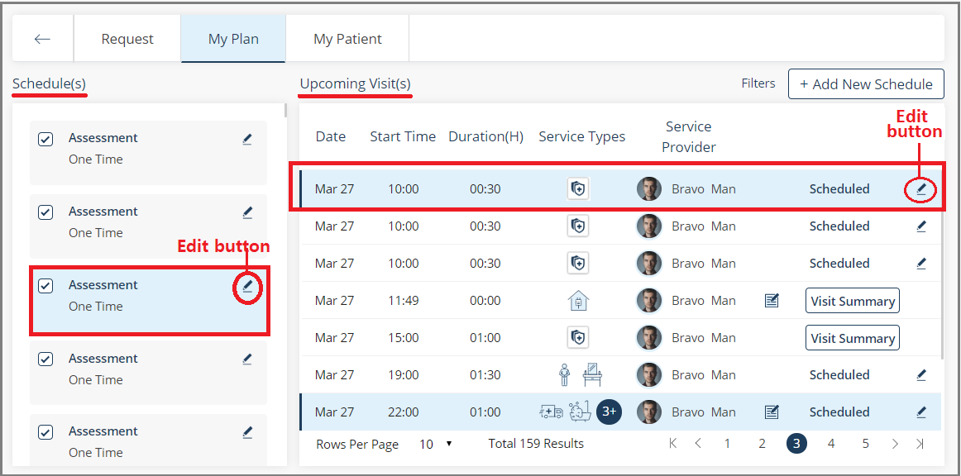

1. My Plan tab
2. To modify a visit plan, click the Edit button (pen icon) for the specified visit under **Upcoming Visit(s)**. To modify a schedule, click the Edit button for the specified schedule under **Schedule(s).** If you modify a schedule, the application modifies all the related visits.

Schedule Type–Standard

The standard schedule-type helps you to create a service request based on the patient’s service needs.

1. Select the schedule type, **Standard**.



1. Add New Schedule–Standard
2. Select one or more service categories – **Activities of Daily Living**, **Help at Home**, **Groceries & Nutrition**, and **Transportation**.
3. Select one or more service types based upon the service category that you have selected.

Schedule the service visit of the care member/service provider to the patient’s home based upon the service request.

1. Select from the two schedule types: **One Time** and **Recurring**.

One Time

Use the **One Time** option to schedule the service visit as a one-time activity.



1. Enter the date that you want to schedule the service visit on in **Start Date**.
2. Choose the start time and the end time of the visit based upon your patient’s service request.

Or,

Recurring

Use **Recurring** to schedule multiple service visits for a period at regular intervals.

1. Select the recurring pattern from the options: **Daily**, **Weekly**, and **Monthly.**



1. For the **Daily** recurring pattern, enter the frequency of visits in **Every** Number of **Day(s)**.

*For example, if the frequency is 2, the visit happens every two days once for the specified period.*

1. Enter the **Start Date** and the **End Date** of the period that you want to schedule the visits for.
2. Select the **Start Time** and the **End Time** of the visit duration.

Or,

1. For **Weekly**, enter the frequency of visits in **Every** Number of **Week(s)**.



*For example, if the frequency is 1, the visit happens every week for the selected days, Monday, Wednesday, Friday, and Sunday, for the specified period.*

1. Enter the **Start Date** and the **End Date** of the period that you want to schedule the visits for, and then specify the timings for the visit duration.

Or,

1. For **Monthly**, enter the frequency of visits in **Day** Number **of every** Number **Month(s)**.



*For example, if it is* ***Day 15 of every 1 Month****, the visit happens the fifteenth day of every month for the specified period.*

1. Enter the **Start Date** and the **End Date** of the period that you want to schedule the visits for, and then specify the timings for the visit duration.

The **Monthly** option also allows you to choose the days on which you can schedule the visits.



*For example,* ***The First Monday of every 1 Month(s)*** *indicates that the visit is scheduled the first Monday of every month for the period that you specify.*

1. On the **Add New Schedule** page, select the point of service. The point of service is the location in your network within which you provide services.
2. Assign a service provider to fulfill the service request. You can assign only those service providers who are affiliated with your entity.
3. If required, you can enter a note in the **Assign Other Service Provider** box to have another service provider fulfill the visit.
4. Click **Save** to save the entries. A plan creates on the **My Plan** tab under **Upcoming Visit(s**).

*For example, if you have scheduled the visit with the following* ***Recurring pattern****:*

* **Monthly**
* **Day 15** of every **1 Month(s)**
* **Start Date –** 03-29-2020 & **End Date –** 07-29-2020
* **Start Time –** 8.30 am& **End Time –** 9.30 am

*The application creates four visits scheduled on April 15, May 15, June 15, and July 15, which you can view on the* ***My Plan*** *tab page.*



1. My Plan tab – with visit details

If you have added a note to include another provider when creating the plan, the note displays in the visit plan.

1. In case you want to modify the visit plan, click the Edit button (pen icon). However, you can edit a plan only when it is in the **Scheduled** status.



1. Edit Visit page

On the **Edit Visit** page, you can modify the start date, time, or re-assign the service providers for the scheduled visit.

Entity Process

In an entity process, the entity user restricts the access of the entity service providers to fulfill the visits for the patients. This scenario arises when an entity or entity service provider uses a third-party application to fulfill the visits but uses Coreo Home to create the plan and schedule the visits.

|  |  |
| --- | --- |
|  | The Coreo Home database has a system configurable parameter which marks whether an Entity can be allowed to process the visits or not, and this happens as a background process. |

In the database, if the parameter is marked for an entity user, then none of the visits scheduled by this entity will be processed.

The entity user engages with a patient and creates the plan and schedules the visit(s) based on the patient’s service request. However, Coreo Home does not process the visit fulfillment scheduled by the entity.

So these planned visits are in **Scheduled** state, and once the date of the visits elapses, the status changes to **Entity Process**.

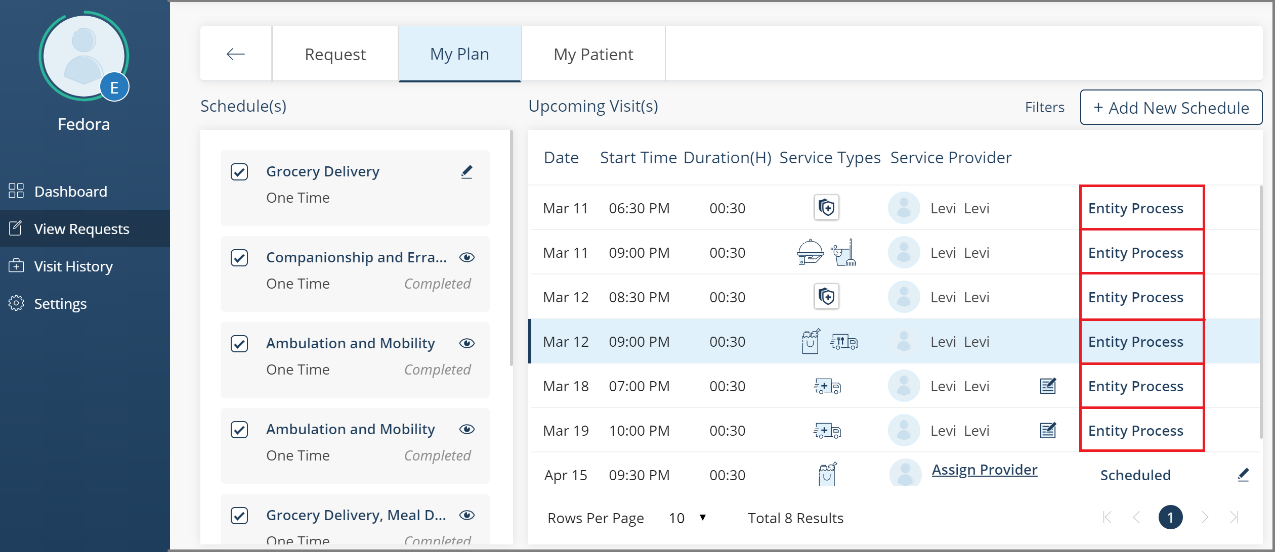

1. Visits with Entity Process status

# Inactive and Deceased Individuals

Individuals are flagged as **Inactive** due to multiple reasons. The primary reasons are when the member doesn’t meet the eligibility criteria of the health plan or when the contract has expired.

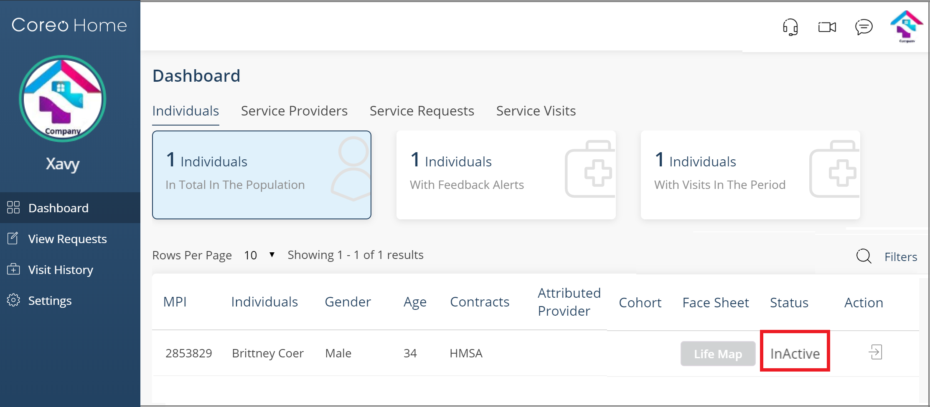

1. Inactive Individual

Though the individual has an **InActive** status, you can still process the service requests. You can add a new schedule, plan visits, and assign a service provider to fulfill the visits.

Similarly, in the case of a deceased individual, you just have the view-access to their account and cannot operate it.

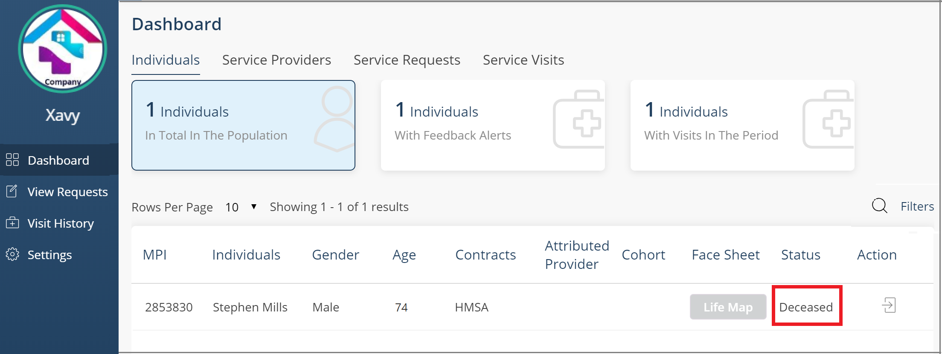

1. deceased individual

For a patient in the **Deceased** status, Coreo Home does the following:

* Cancels all open visits - scheduled visits and overdue visits
* Cancels all service requests including **Open**, **Engaged**, and **Pending Approval**
* The visits with the status, **In Progress** and **Completed** on the **My Plan** tab page, continue to remain in the same status. Coreo Home provides this capability so that you can track the billable visits of the deceased patients.

You cannot perform any action in the account of a patient with **Deceased** status.

|  |  |
| --- | --- |
|  | The central administrative system configures the Coreo Home database to synchronize itself with the Coreo Analytics data for inactive and deceased patient records.  The synchronization process is automated and runs as a background job in Coreo Home. The periodicity of data synchronization can be set as nightly sync (24 hours) or can be changed as required. |

Section IV: Entity Service Provider (ESP) User

# ESP Onboarding

The onboarding process of an Entity User and an Entity Service Provider is similar. Please refer to the Entity User Onboarding topic in this user guide for information on how to onboard an Entity Service Provider.

# ESP Profile

Help your employer to learn more about you by completing your profile.

Be sure to include your profile image in addition to your personal details. The profile image helps the organization that you are associated with, know who you are. Preferably, upload a clear and recent image.

You can update or review your profile details:

1. Select the profile logo on the side menu or the upper-right corner of the header bar.

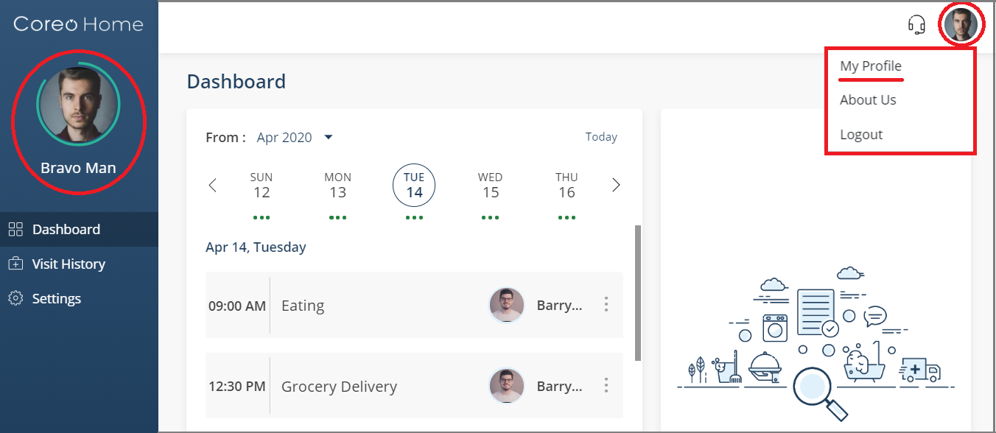

1. entity service provider Dashboard
2. The **Profile** page opens. Select the **Edit** button (pen icon) in the upper-right corner of the **Profile** page.
3. The **Edit Personal Details** screen opens.

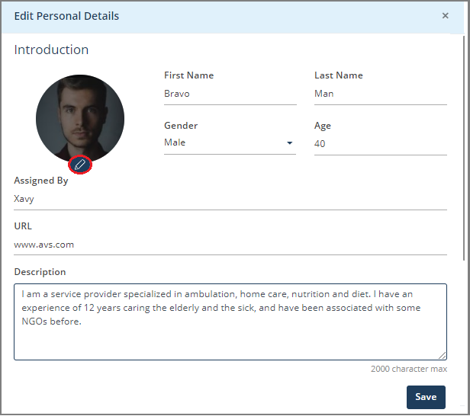

1. Edit Personal Details
2. Select the edit button (pen icon) on the profile logo and upload your recent image.
3. Add the following to your profile; your **First Name**, **Last name**, **Gender**, and **Age**.

The **Assigned By** box displays the name of the organization/entity that you are associated with, and the **URL** displays the Web address of the organization.

1. Include a brief description of yourself in the **Description** box.
2. Scroll down the screen and enter your address details and your phone number.
3. Click **Save** to save the changes and navigate back to the **Profile** page.
4. On the **Profile** page, under **Education**, click the plus icon (Ꚛ) to enter your education details. You can enter one or more educational qualifications.

# Dashboard

Your dashboard is the main screen you see when you sign in to your Coreo Home account.

View all your scheduled service visits in one place on the dashboard. The calendar view helps you to sort your visits based on the date.



1. Dashboard

Click the **From** arrow and select the month for which you want to view the scheduled visits. The related service visit cards are shown.

The horizontal dots below each date indicates that the visits are scheduled for the day. One dot implies one visit; two dots - two visits; however, three dots indicate three or more than three visits.

You can use the left chevron icon (<) to navigate to the starting days of the month and the right icon (>) to navigate to the later part of the month.

A service visit card displays the time at which the visit starts, the type of services to be provided to the patient, and the patient’s name.

Click the three vertical dots icon next to the patient’s name in a service visit card and start the visit process. You can choose to phone the patient directly.

Coreo Home Mobile Device App for ESPs

Download the Core Home mobile app for the service providers on your smartphone or tablet and sign in to your user account.

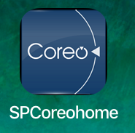

Coreo Home mobile app icon – Service Provider

The screens in the Coreo Home Web and the Mobile app have the same foundational structure with slight variation in the way you navigate through the app. The variations in the mobile app are summarized here.

You can navigate through the app using the bottom tab bar. The **Dashboard** screen in the mobile app is as illustrated:

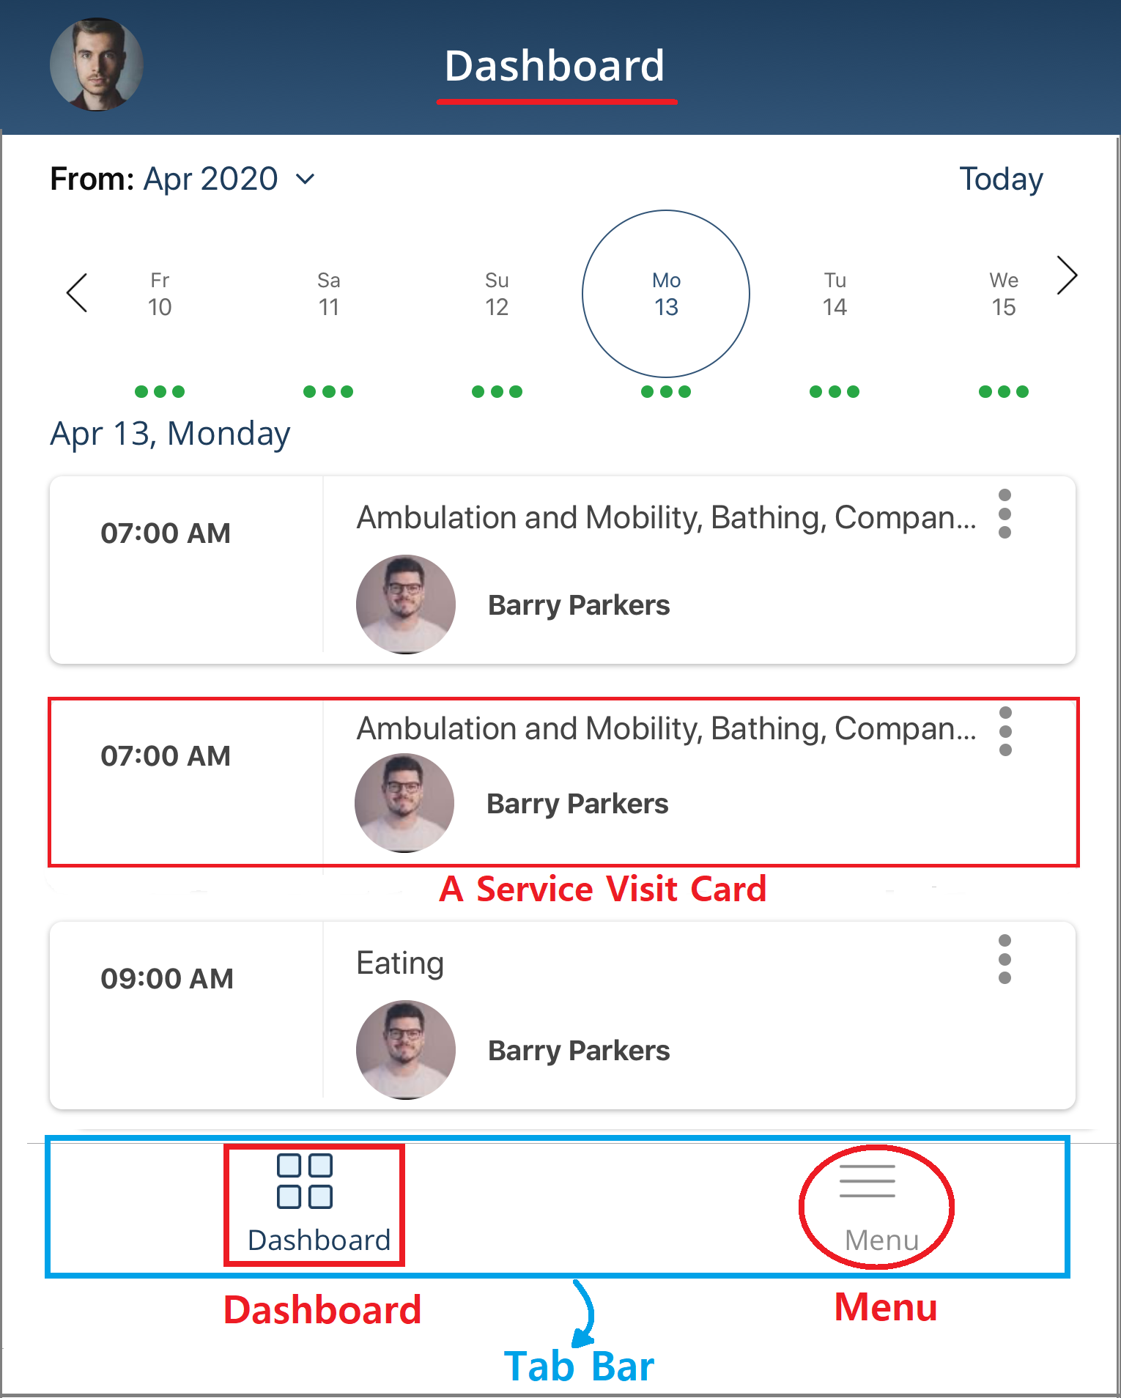

1. Dashboard

Even in an offline mode, when network access is not available, you can fulfill a visit process.

## Start the Visit Process

The Visit Processing includes the following steps:

* Recording the start and stop time of the visit to the patient’s location
* Record a mini-assessment as feedback, and
* Record closure of tasks.

Note that the benefit-processing or credit card payment processing is not available for Entity Service Providers.

Fulfill the visit process:

1. On the dashboard, select the service visit card that you want to fulfill the visit process for. The **My Plan** tab page opens.



1. My Plan tab page
2. Use the **Filters** button or scroll the page to find the specified service visit card.
3. Select the **Start Visit** button to initiate the visit process in Coreo Home at the patient’s location.

|  |  |
| --- | --- |
|  | The **Start Visit** button is not available for an entity process. Refer to the Entity Process topic in this user guide under the Entity User section for more information. |

1. On the **Visit Processing** screen, click **Start Service** to start the visit process.
2. On completing the assigned tasks for the patient, select the respective service type arrows, and mark them complete. When you tick all the tasks, The **Tasks** bar is 100% complete.



1. Visit Processing screen–Stop Service
2. Click the **Stop Service** button on the **Visit Processing** screen to stop the services. The total time that you have utilized to complete the tasks is displayed. Then, select the **Next** button.
3. Answer the feedback questions regarding the visit that you completed. However, you can skip this step.
4. View the visit details on the summary screen.



1. Visit Processing–Summary screen
2. Ask the customer to review the details and put the digital signature.
3. Save the signature and click **Done** to complete the visit process.
4. Once you complete the visit process, the visit status changes to **Visit Summary** on the **My Plan** tab page.



1. Click the **Visit Summary** button to view the visit details on the **Visit Summary** page.



1. Visit Summary page

You can view the fulfilled service visits on the **Visit History** page. On the side menu, select **Visit History** to open the **Visit History** page.

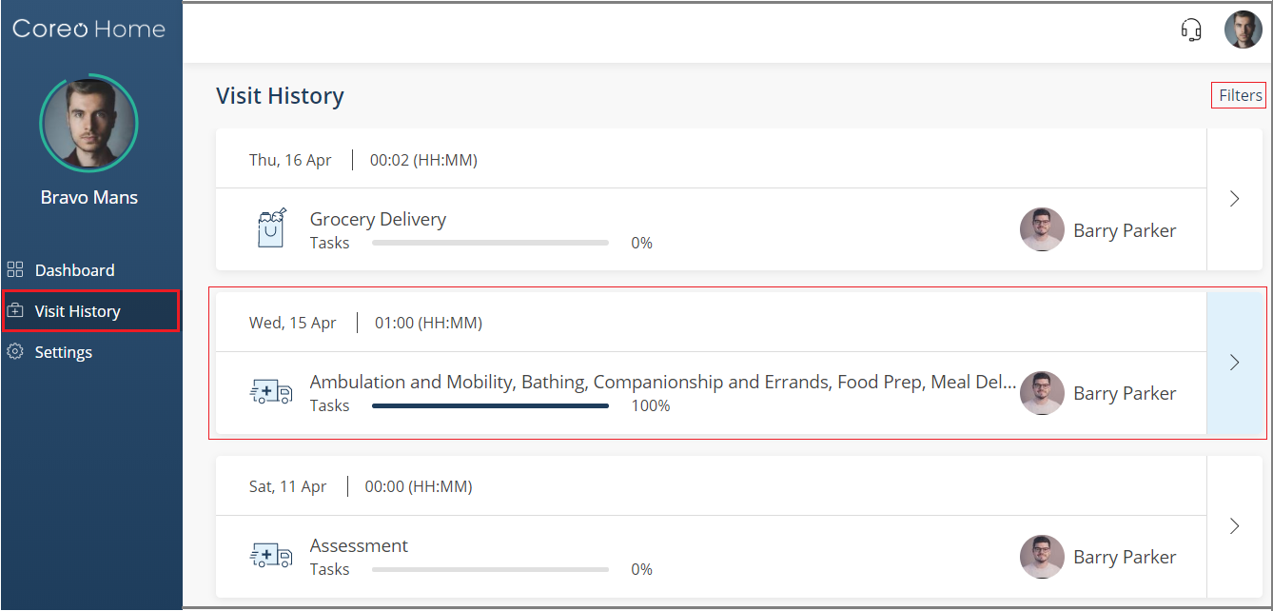

1. Visit History page
2. Use the **Filters** button or scroll the page to find the specified service visit card. Select the right-arrow in the card to view the summary of the completed visit on the **Visit Summary** screen.

|  |  |
| --- | --- |
|  | If the patient has an **InActive** status, you can still fulfill the visits scheduled for them.  You cannot perform any action in the account of a patient with **Deceased** status.  Refer to the Inactive and Deceased Individuals topic under the Entity User section in this user guide for similar information. |

In the mobile app, to open the **Visit History** page, click the **Menu** button on the tab bar to go to the **Menu** screen, and then click **Visit History**.

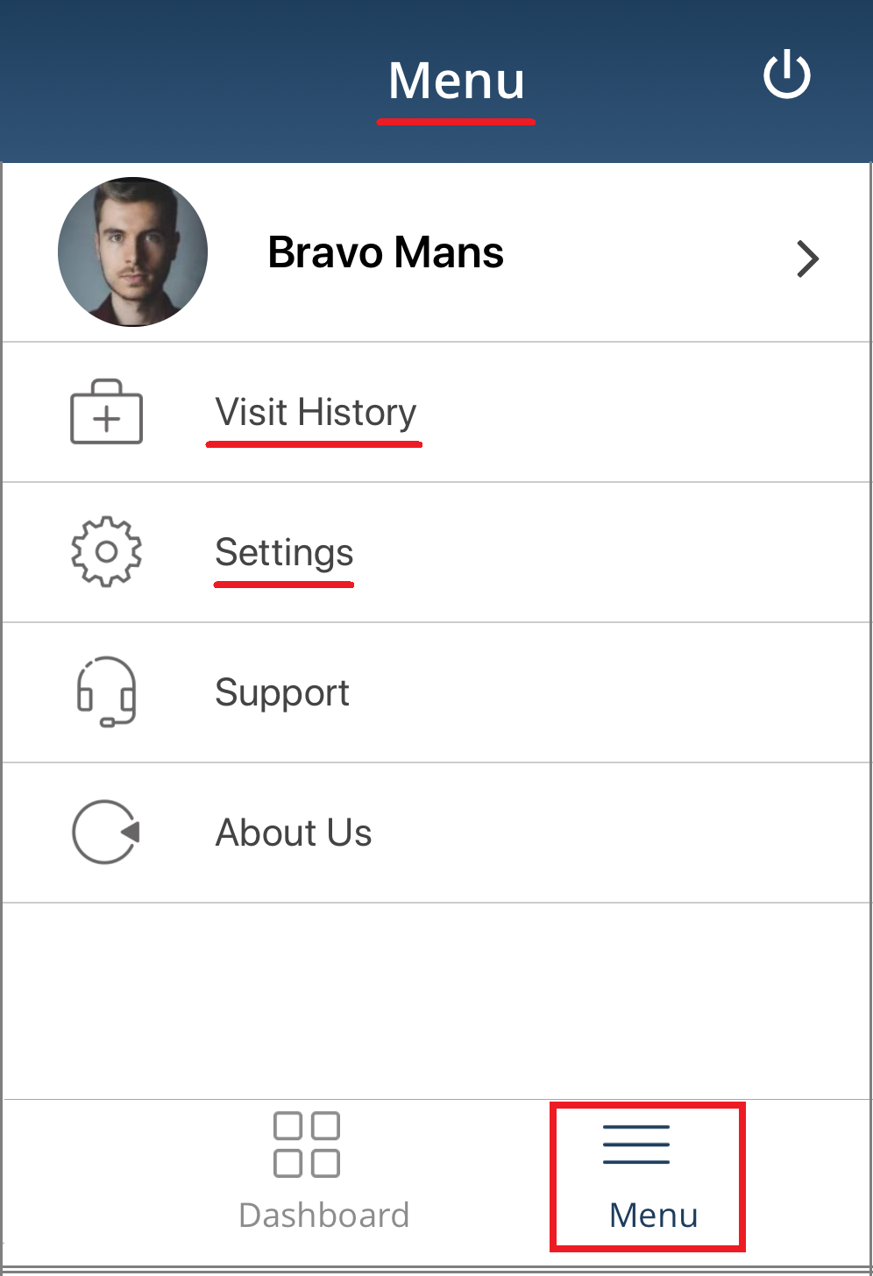

1. Menu screen

Click **Settings.** You can set how toreceive your notifications for Coreo Home on the mobile app.

When you are in an offline mode, out of the network access, you can continue using Coreo Home, and you can still go ahead and complete a visit process.

Section V: Care Team User

# Care Team Dashboard

A Care Team member can fully act on behalf of an Individual and perform any action on the Coreo Home platform as the Individual user. You can also authorize a patient service request when required from the Care Team dashboard.

Your dashboard is the main screen you see when you sign in to Coreo Home. View the summary under the following tabs:

|  |  |  |  |
| --- | --- | --- | --- |
| **Individuals** | **Service Providers** | **Service Requests** | **Service Visits** |

## Individuals Tab

The **Individuals** tab has four subtabs:

1) Individuals in Total in the Population

The **Individuals in Total in the Population** subtab shows the total number of individuals (patients) assigned to you and who are engaged with various service providers within Coreo Home.

The care team member can view only those patients assigned to them by the administrator based upon the contracts the patients hold.

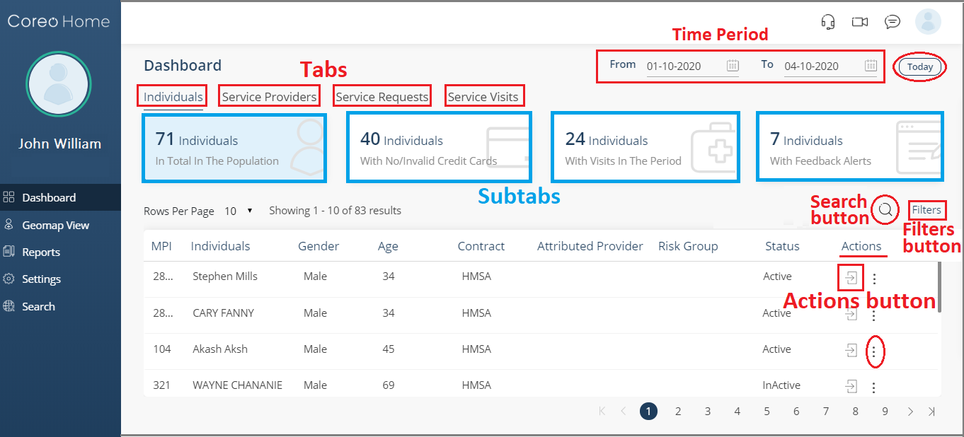

1. Individuals tab–Individuals in the Total Population subtab

Based upon the subtab that you select, you can view the details of the individuals, such as the individual’s name, gender, age, name of the contract, provider’s name, individual’s risk group, and the account status.

You can use the Search button to search the records in the lower pane of the window based upon the individual’s name that you enter in the Search box.

Select the vertical three dots icon for an active patient to open a drop-down list consisting of the **Phone Call**, **Conversation**, and the **Video Conferencing** options.

Select the period that you want to view the records for, or select **Today** to view the records of the current day.

Similarly, you can use **Filters** to display only those records based on these filter criteria: Contract, Risk Group, Attributed Providers, Gender, Clinical Conditions, Age of the individual, and their Gender.

Care Team User Acting on Behalf of the Patient

As a care team member, you have full access to the individuals’ accounts who are assigned to you.

On the **Individuals in the Total Population** subtab, each individual’s details are displays in a row with an **Actions** button towards the end of the row.

Click the **Actions** button to navigate to the individual’s account.

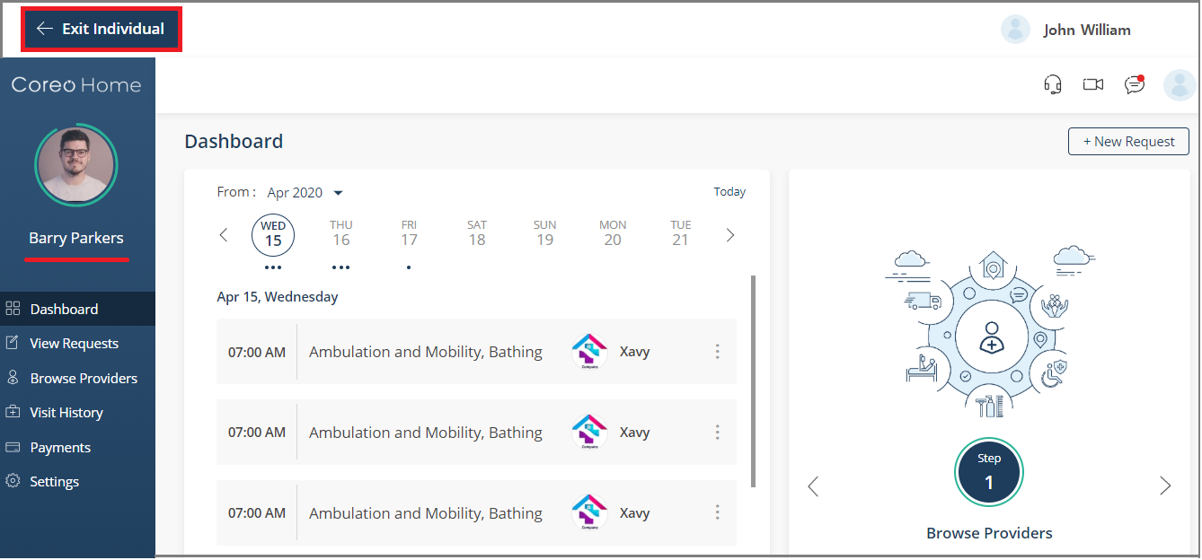

1. individual’s account

You can access an individual’s account and assume their role to perform all those actions and tasks that an individual user can do.

At any time, you can use the **Exit Individual** button at the upper-left corner of the screen to navigate back to your account.

Refer to the Individual User section in this User Guide for complete information on how to operate an individual’s account

Mobile App Interface for Care Team Users

Download the Core Home mobile app on your smartphone or tablet and sign in to your user account.



Coreo Home mobile app icon – care team

The screens in the Coreo Home Web and the Mobile app have the same foundational structure with slight variation in the way you navigate through the app. The variations in the mobile app are summarized here.

You can navigate through the app using the bottom tab bar

The **Dashboard** screen in the mobile app is illustrated below for **Individuals** tab with its related subtabs. The screen navigation and UI elements are the same for the other tabs:

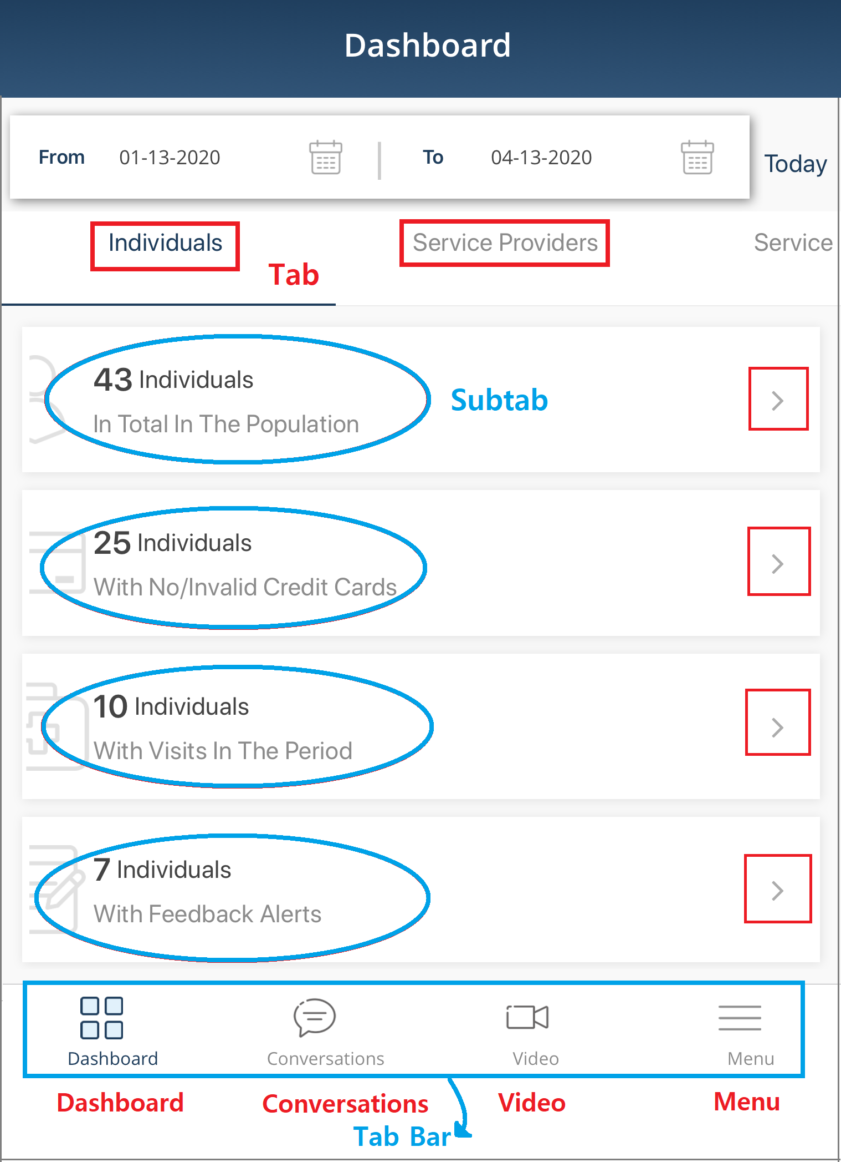 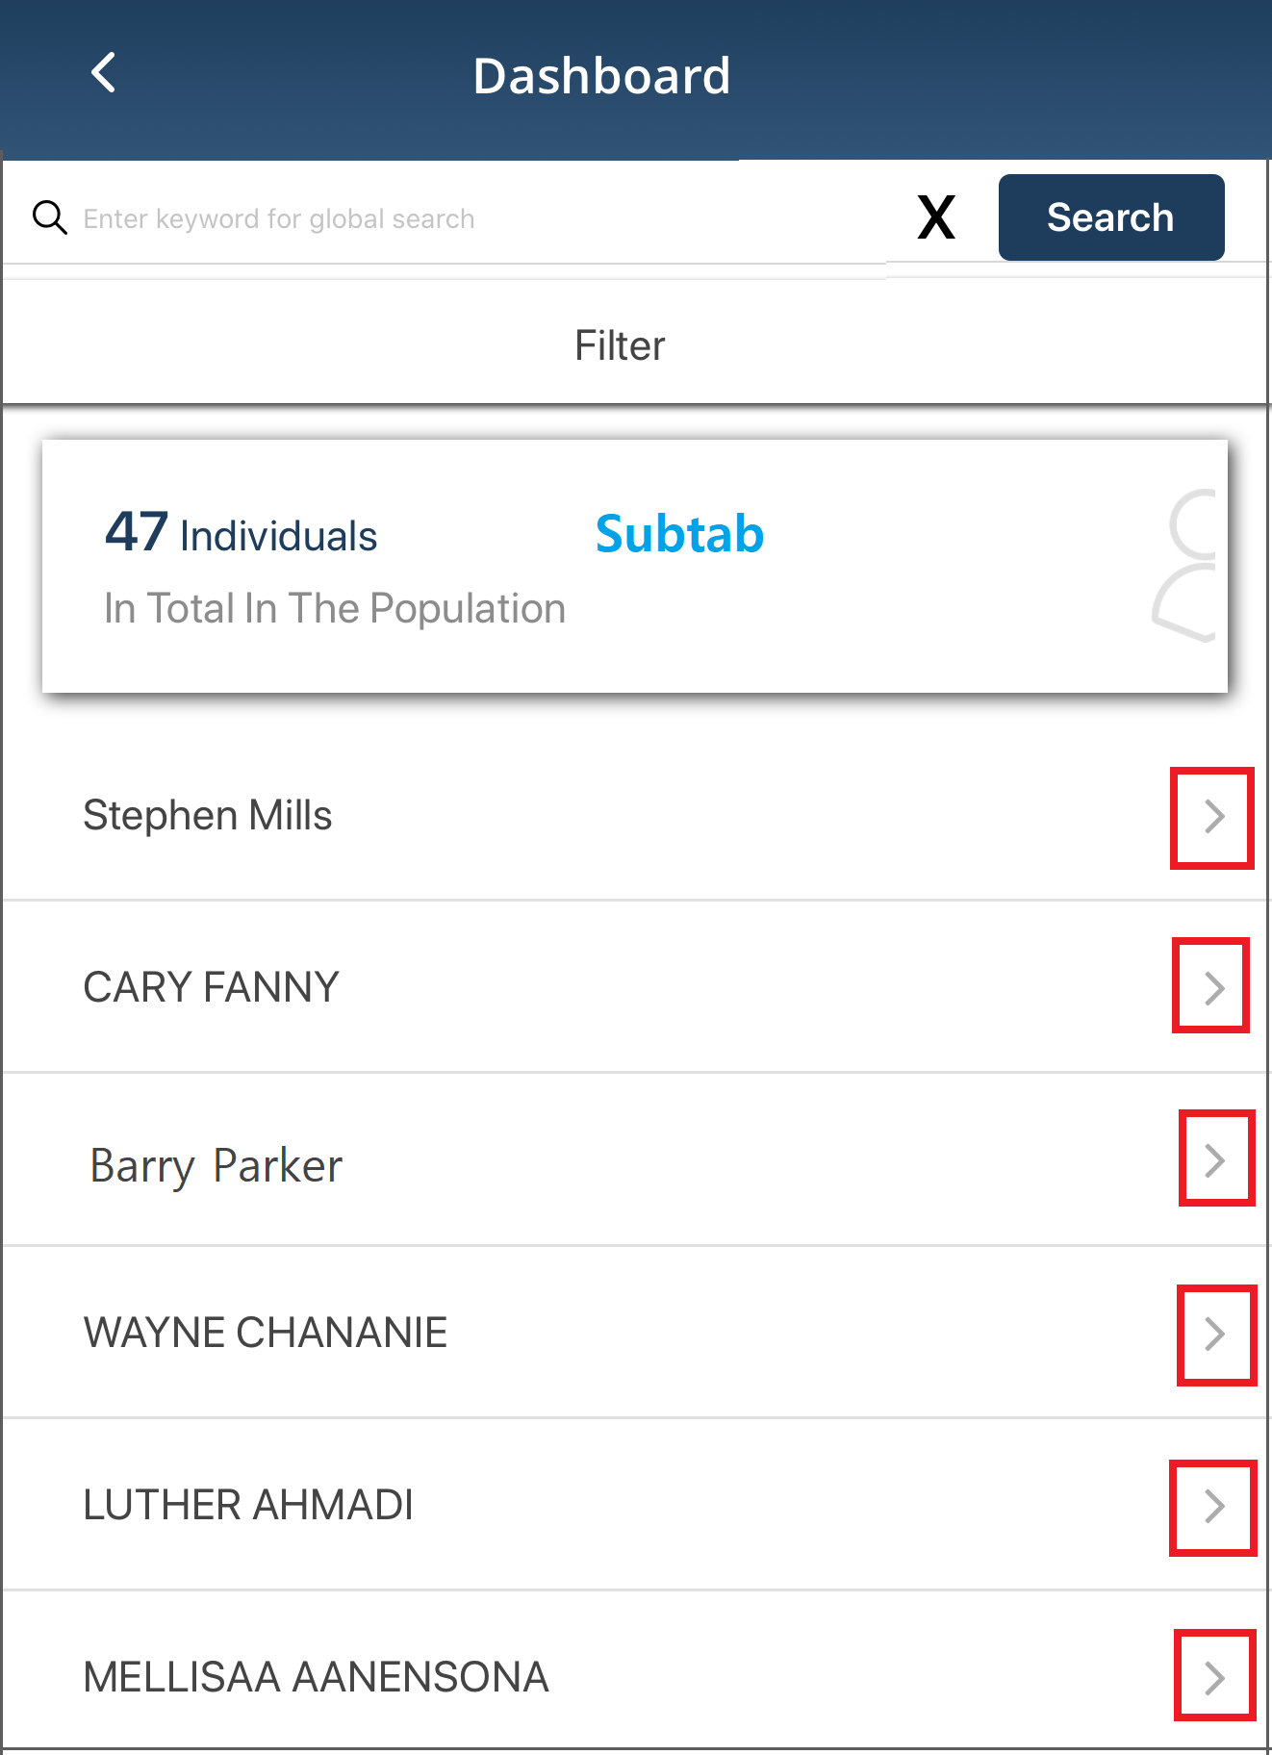

1. dashboard–tab screen figure b. subtab screen

Select the subtab arrow-icon to open the subtab screen where you can view the details of the individuals.

On the subtab screen, each row has an arrow icon. Select the arrow to expand the row.

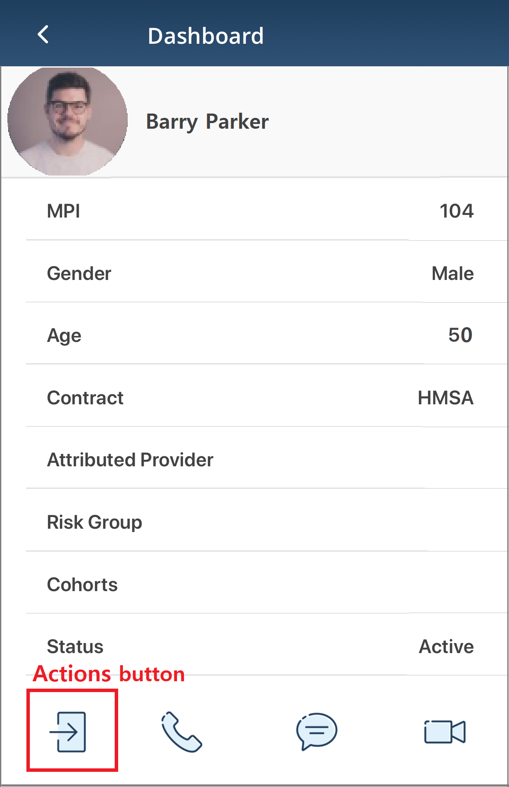 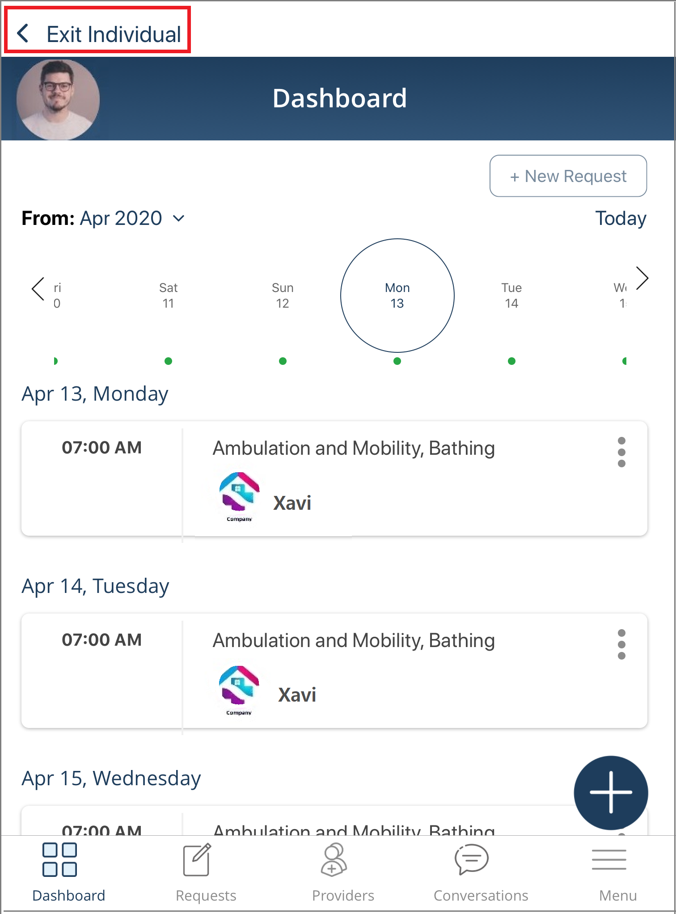

1. Row details screen Figure b. Individual’s Account

Select **Actions** on the tab bar to navigate to the individual’s account.

Refer to the mobile app **Dashboard** screen of an Individual user for information on how to navigate through the screens.

2) Individuals with No/Invalid Credit Cards

The subtab displays the total number of assigned individuals who have not entered the credit card details in their Coreo Home user account, and those with invalid or incorrect card entries. You can view the details of such individuals listed as rows in the lower half of the screen.

Click the **Actions** button to navigate to the individual’s account, and on the side menu, select **Payments**. The **Saved Card(s**) box is blank when the user does not enter the credit card details.

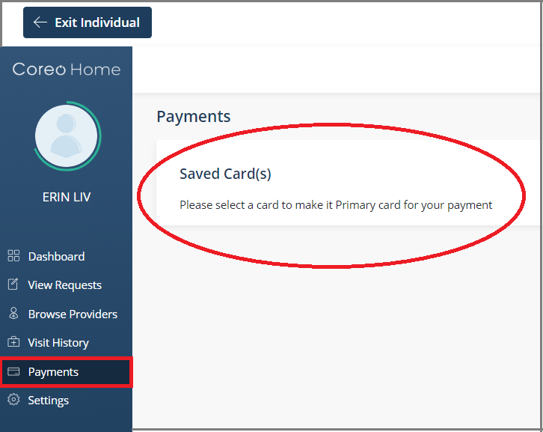

Note that the payments are processed only by individual service providers.

3) Individuals with Visits in the Period

The **Individuals with Visits in the Period** subtab shows the total number of individuals who have their visits scheduled from their service providers during a specified period.

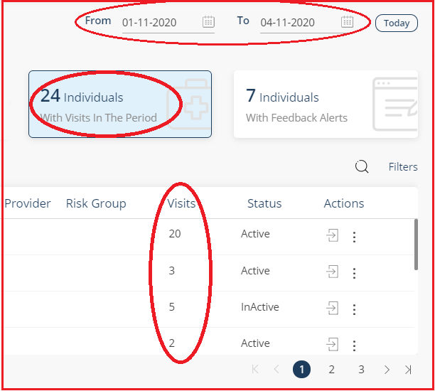

Select the **From** date and the **To** date of the period for which you want to view the visit details. Or, select the **Today** button to view the visit details of the individuals for the current date.

The total number of service visits for each individual user displays in the **Visits** column.

4) Individual with Feedback Alerts

Refer to the Individual with Feedback Alerts topic under the Entity User section in this user guide for more information.

## Service Providers Tab

The **Service Providers** tab has five subtabs:

1) Providers in Total in the Population

The **Providers in Total in the Population** subtab shows the total number of service providers that are assigned to you by your administrator.

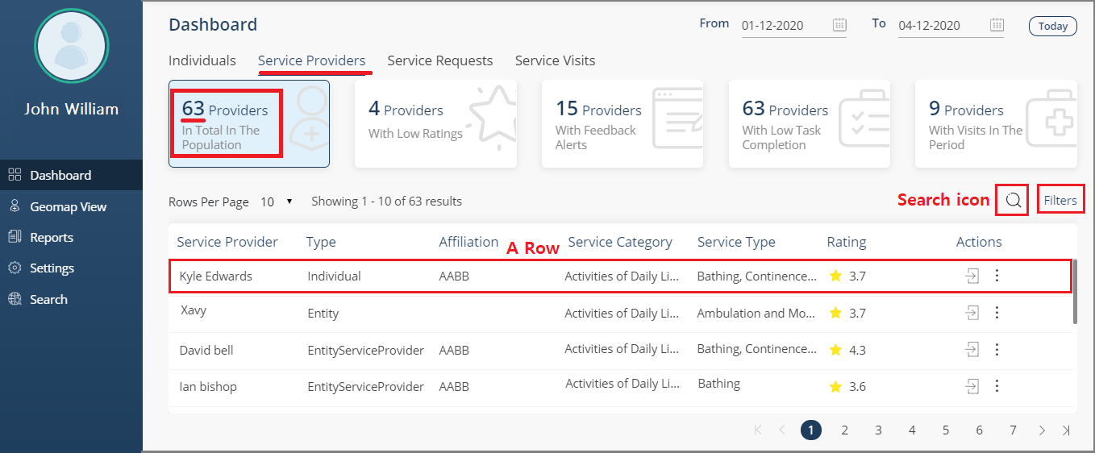

1. Service Providers tab–Providers in Total in the Population subtab

The details of the service providers display in each row in the lower half of the screen, and the details include the following:

* The name of the service provider
* Provider type – Individual (Individual Service Provider), Entity, Entity Service Provider
* Affiliations – The various organizations and bodies the provider is affiliated with
* The service categories and the service types that the provider is offering services for
* The ratings of the provider
* The Actions icon: Click it to view the service provider’s profile.
* Vertical three dots icon: Click it to start a phone call, chat, or video conference with the provider.

To search the records based upon the provider name, use the **Search** icon.

Use **Filters** to display only those service provider records based on the filter criteria – Service categories and types, Hourly Rate charged by an individual service provider, Skills, Gender, and Ratings of the providers.

2) Providers with Low Ratings

Refer to the Providers with Low Ratings topic under the Entity User section in this user guide.

3) Providers with Feedback Alerts

Refer to the Providers with Feedback Alerts topic under the Entity User section in this user guide.

4) Providers with Low Task Completion

Refer to the Providers with Low Task Completion topic under the Entity User section in this user guide.

5) Providers with Visits in the Period

Refer to the Providers with Visits in the Period topic under the Entity User section in this user guide.

## Service Requests Tab

The Service Requests tab has four subtabs:

1) Requests in Total in the Population

You can view the total number of service requests posted by the customers/patients assigned to you.

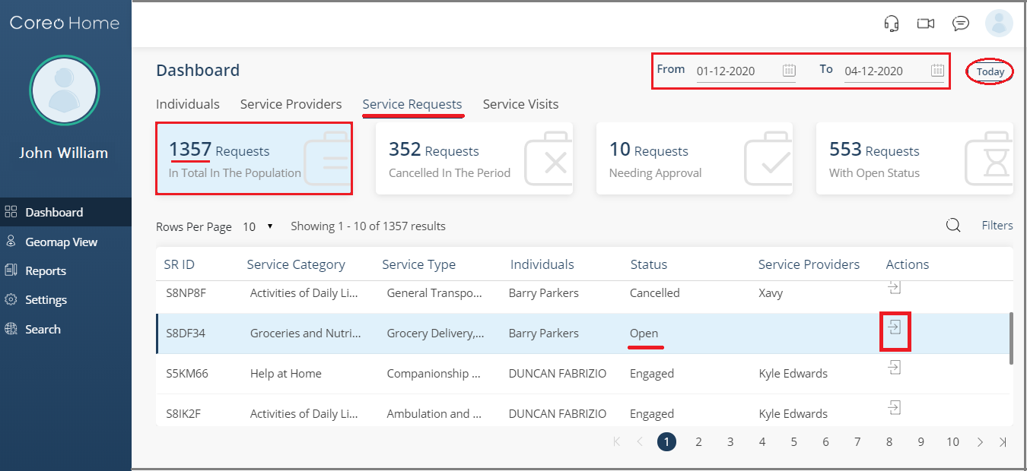

1. Requests in Total in the Population subtab

Click the Actions icon to open the **Request** tab page. The details of the service request display on this screen.

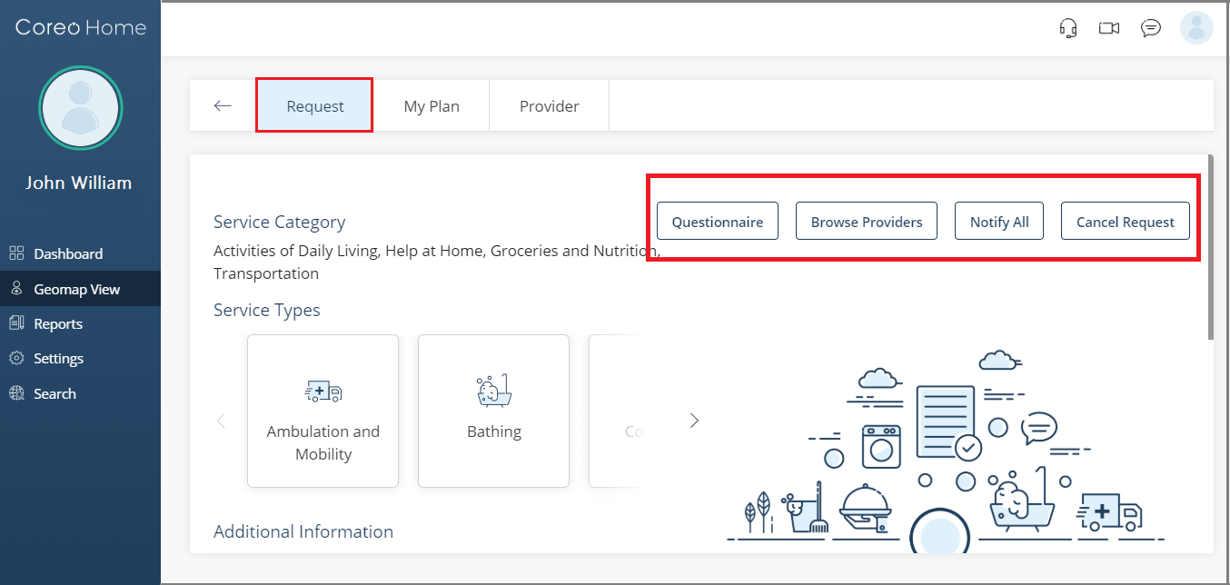

1. Request tab page

As a care team member, you can act on behalf of the patient or the guardian, and make these changes to service requests on the **Request** tab page:

* Create and post a service request: As the first step towards creating and posting a service request, click the **Browse Providers** button. You can post a request only if it’s in the **Open** status.
* Notify providers: Click **Notify All** button to send notification about the service request to all those service providers who are within the radius of the patient’s location.
* Cancel a service request: For a service request in the **Open** or **Engaged** status, click the **Cancel Request** button on the Requests screen to cancel the service request.
* Cancel a service visit: On the **My Plan** tab page, you can cancel a scheduled service visit if the service provider is of type **Entity**.

For information on creating a service request, posting a service request, canceling service visits, and more, refer to the Individual User section and the Guardian User section in this User Guide.

2) Requests Cancelled in the Period

3) Requests Needing Approval

When customers post service requests with the **Transportation** service category, they have to be approved by a care team member before assigning the requests to the service providers.

As a care team member, you can approve the service requests with the **Transportation** service category on the **Requests Needing Approval** subtab.

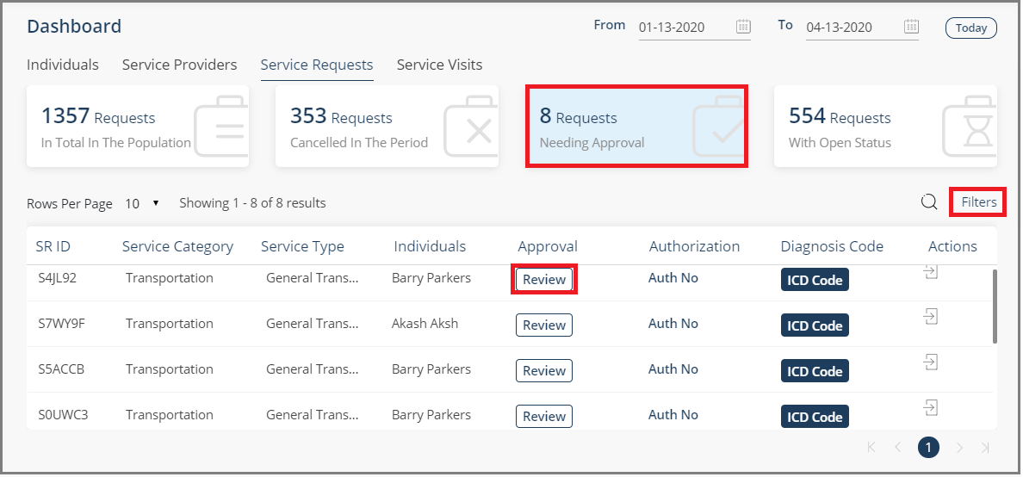

1. Requests Needing Approval subtab

Select the **Review** button for the individual that you want to approve the request for. The **Approve Request** form opens.

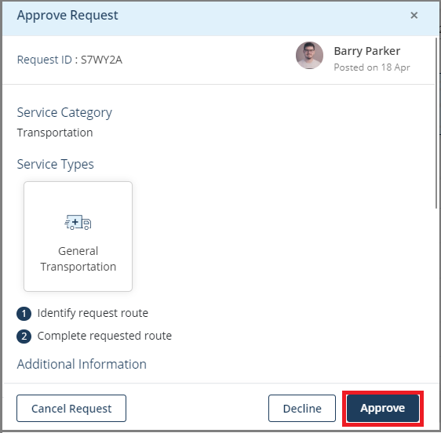

1. Approve Request form

Review the request and select either the **Approve** button to approve the request or the **Decline** button to decline the request.

Select **Yes** in the message box to confirm that you want to approve/decline the service request.

If you choose to revoke the already given approval, Coreo Home gives you the flexibility to decline an approved request or approve a declined request.

To revoke the approval, do this:

1. Select the **Filters** button on the **Requests Needing Approval** subtab, and then select the **Approval Status** filter criterion.
2. Tick the **Approved** and **Declined** status and select **Apply** to filter the rows based on the **Approved** and the **Declined** approval status.

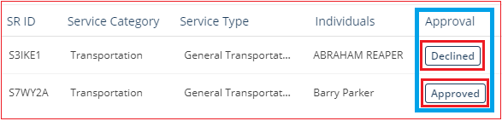

1. Select the **Declined** button under **Approval**. The **Approve Request** form opens. Review the request and select the **Approve** button.
2. Similarly, to decline an approved request, select the **Approved** button. Select the **Decline** button in the **Approve Request** form.

4) Requests with Open Status

## Service Visits Tab

The **Service Visits** tab shows the details about all visits of the patients assigned to you by your administrator.

Refer to the Service Visits tab topic under the Entity User section in this user guide for more information.

# Handling Inactive and Deceased Individuals’ Accounts

You can operate an account of an inactive patient similar to that of an active account.

On behalf of an inactive patient, you can create a new service request and engage with the service providers.

The service provider can engage with inactive patients by accepting their service requests, create visit-plans, and can fulfill the planned visits.

You cannot perform any action in the account of a patient with **Deceased** status.

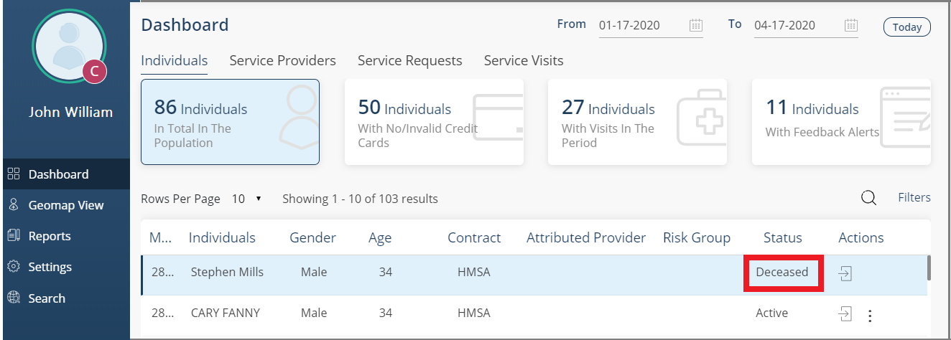

1. Status–deceased patient

Refer to the Inactive and Deceased Individuals topic under the Entity User section in this user guide for similar information.

# Video Conferencing and Messaging

Refer to the following links for information on these features:

Video Conferencing

Messaging

Header bar

# Geomap View

Use the geomap view feature to display the location details of patients and service providers on a geographical map.

Select **Geomap View** on the side menu to open the geomap view layout.

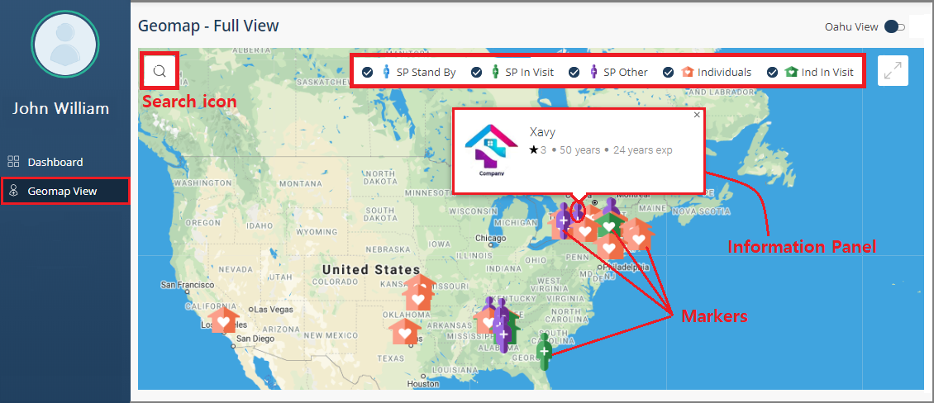

1. Geomap View

You can view a horizontal bar on the upper part of the screen with the following check boxes:

|  |  |
| --- | --- |
|  | Select the check box to display the location markers on the geomap of those service providers who are in the standby mode.  On clicking the marker, an information panel opens with brief details about the service provider. |
|  | Select the check box to display the location markers on the geomap of those service providers who are currently fulfilling the visit process at the patient location.  Click the marker to open the information panel. |
|  | Select the check box to display the location markers on the geomap of the other service providers assigned to you, excluding those in the standby mode and those fulfilling visits.  Click the marker to open the information panel. |
|  | Select the check box to display the location markers on the geomap of the individuals assigned to you.  Click the marker to open the information panel, which displays the individual’s name and the address details. |
|  | Select the check box to display the location markers on the geomap of those individuals who are currently being visited by the service provider fulfilling the service request.  Click the marker to open the information panel, which displays the individual’s name and the address details. |

You can use the Search icon button in the upper-left corner of the geomap layout to search for the service providers and individuals by entering the zip code.

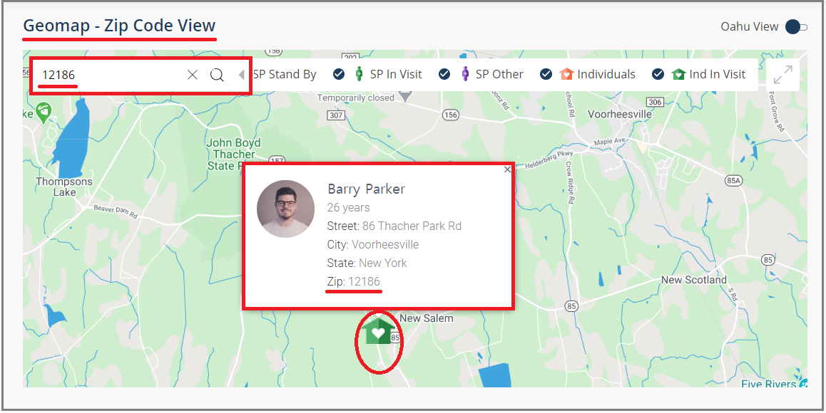

1. Geomap – Zip Code View

# Glossary

**Assessment:** Individual users are required to answer an assessment related to the service request. The questions and answers shall be available to service providers and entity users reviewing the service request.

**Caregiver**: The person sent by your service provider to assist you based on your service request and the type of service category.

**Coreo Analytics**: The Coreo Analytics application has the master list of all patients, which can be fetched in Coreo Home based on the customer specification.

**Entity**: Home health agencies or organizations

**Feedback Alerts**: The Care Team and the Entity Users can view a set of individuals or service providers associated with an assessment-answer in the feedback section, which results in a feedback alert.

**Guardian**: A guardian is a person supporting one or more individuals needing services.

**Inactive Patient**: The care team has the provision to view only those patients that have inactive contracts in Coreo Analytics. Based on the client’s policy, they can decide whether inactive patients may continue utilizing the Coreo Home platform. The application flags the patients as **Inactive** due to multiple reasons. The primary reasons are when the member doesn’t meet the eligibility criteria of the health plan or when the contract has expired.

**Individual**: A patient or a dependent member in need of services.

**Page**: The terms page and screen are used interchangeably in the context of the Coreo Home application.

**Plan:** An entity creates a service plan as a result of the entity being engaged with the patient to fulfill a Service Request. A service plan contains several schedules based upon which the entity processes the planned service visits by assigning them to the entity service providers.

**Service** **Category**: The service categories in Coreo Home include **Activities of Daily Living**, **Help at Home**, **Groceries and Nutrition**, and **Transportation**.

**Service Provider**: A service provider may be an individual caregiver or an entity like Meals on Wheels. The dashboard of the patient and guardian users provides a directory of service providers.

**Service Request**: Patients, Care Team, and Guardians can create a needs-request which specifies services that they are requesting. Each Service Request includes service categories, which in turn include service types. A service provider fulfills a service request.

**Service** **Type**: Each service category includes one or more service types. For example, the service category, **Groceries and Nutrition** includes service types, **Grocery Delivery** and **Meal Delivery**.

**Task:** There are one or more service tasks under each service type. For example, the service type, **Grocery Delivery** includes tasks, **Generate grocery order** and **Deliver grocery order.**

**View Visit Calendar**: A calendar view on the dashboard detailing all service visits on the associated date.

**Visit**: A service visit fulfilled by the service provider based upon the service request posted by the patient and the service plan created by the entity.

Index

[Depending on the size or complexity of the final document, insert an index to assist the user in locating specific information. Index entries correspond to tags or categories, and are useful in navigating long books.]

[Index term – *page number*]

[Index term – *page number*]

[Index term – *page number*]

Please Note: The Index will be generated just before the Print-Ready PDF generation as the page numbers are going to change.